# INDEX

**Date:5/08/2024**

**Day-1**

1. Languages and Applications.
2. Introduction to Java
3. Java Feature's
4. Why JAVA is Platform Independent

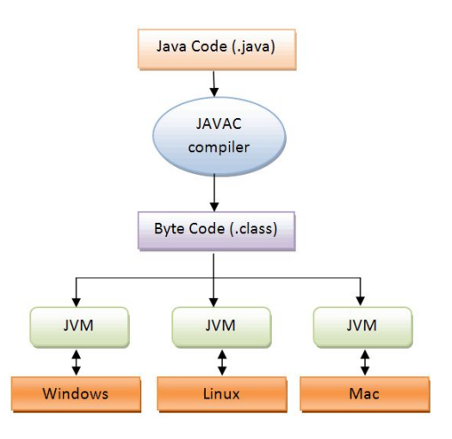

**Java Feature's**

* 1. Platform Independent
  2. Open Source
  3. OOPS Concept
  4. Garbage Collection(Memory Management)
  5. Exception Handling
  6. Inbuilt Multi-Threading
  7. Secure(Security)
  8. Supports web Technologies

1. JDK,JRE,JVM

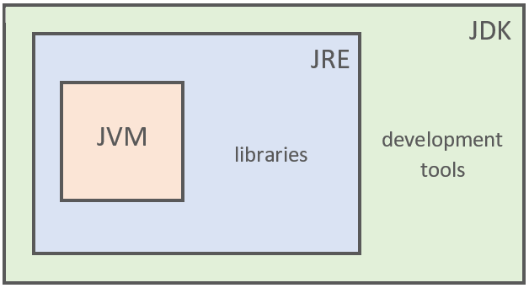

1. Operator's
2. Condition Statements & Loops(if and else if)(remaining basics)
3. Packages
4. Basic programs: biggest of 2, 3 and 5 numbers.(Individual programs for each)
5. Swapping of two numbers without using third variable.

Biggest of 2 numbers

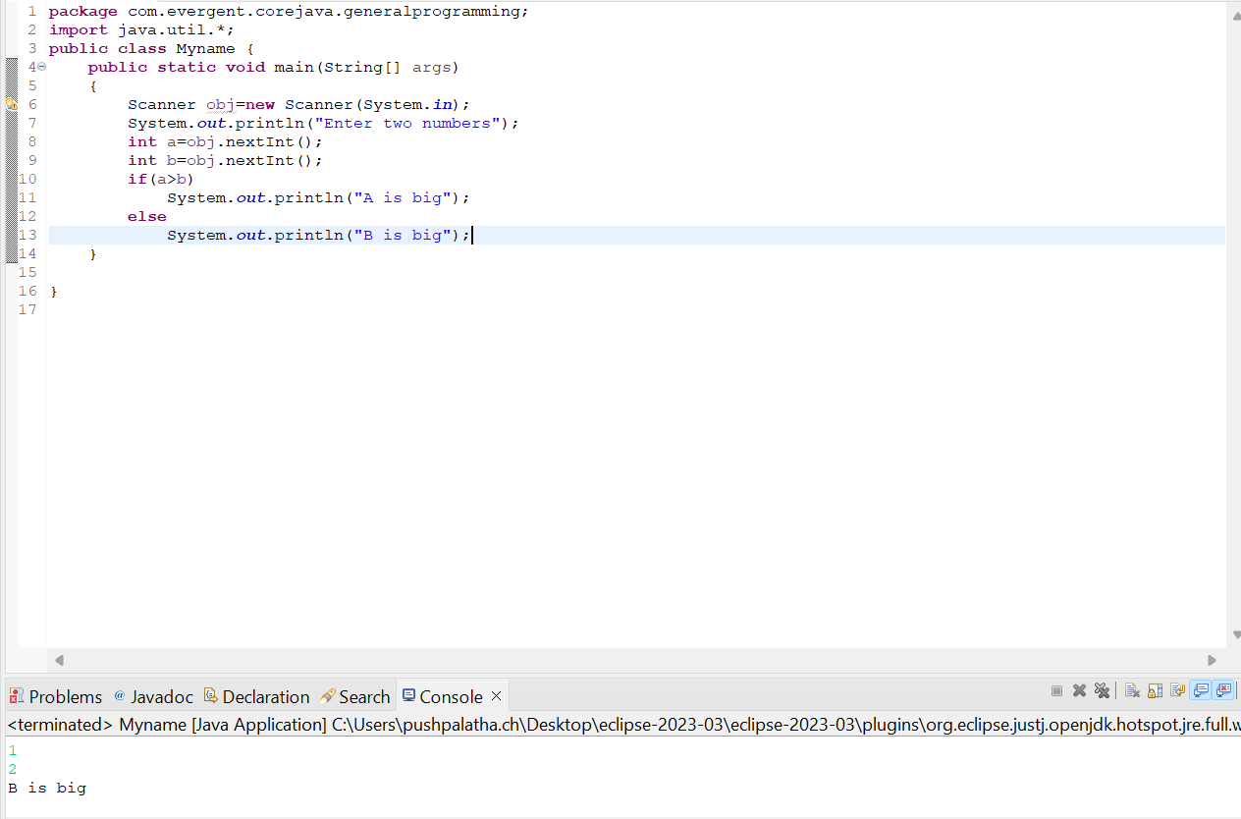

Biggest of 3 numbers

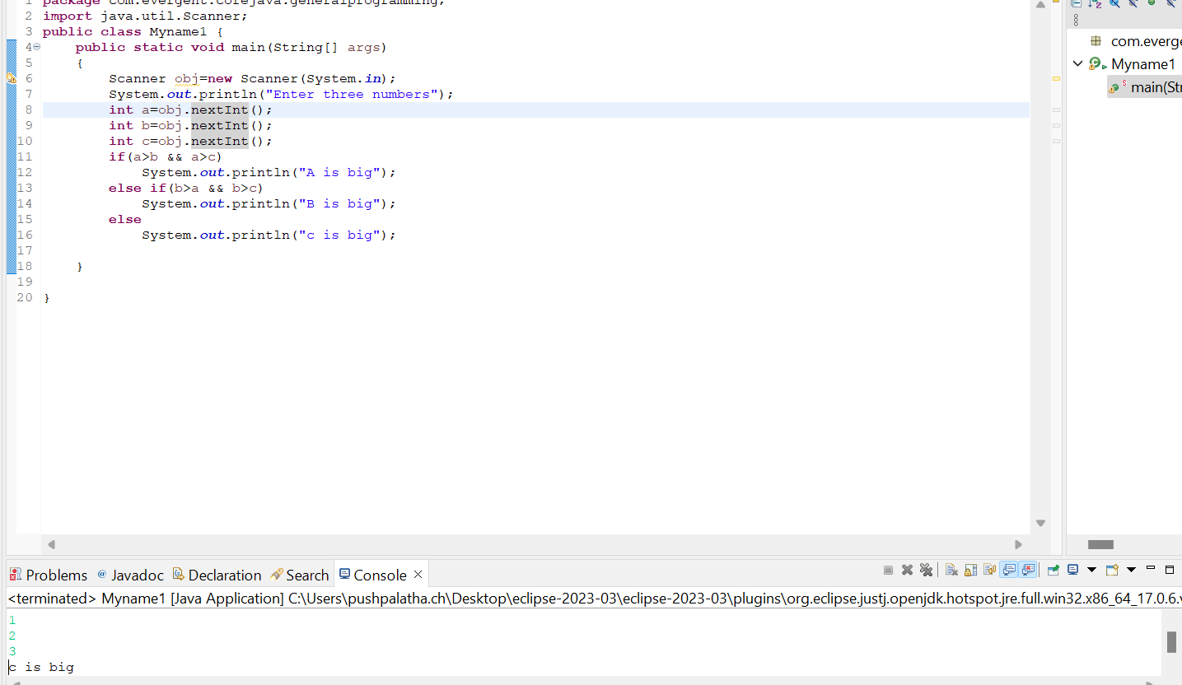

Biggest of 5 numbers

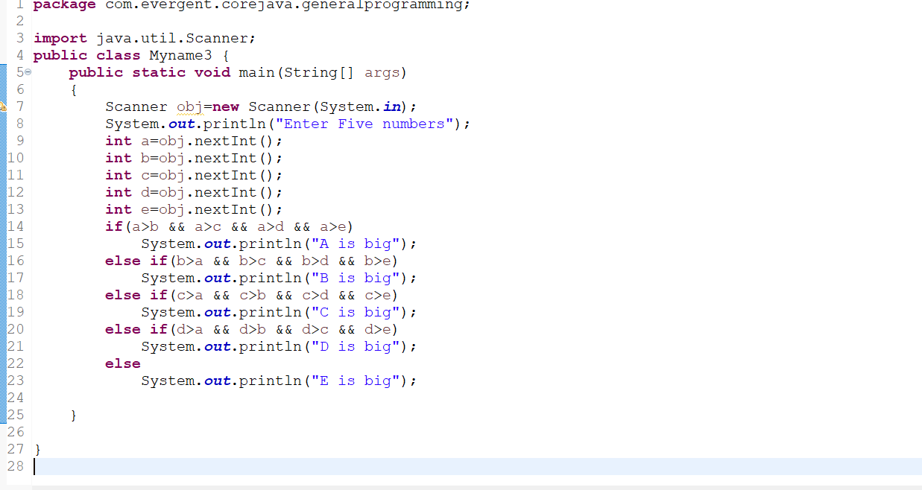

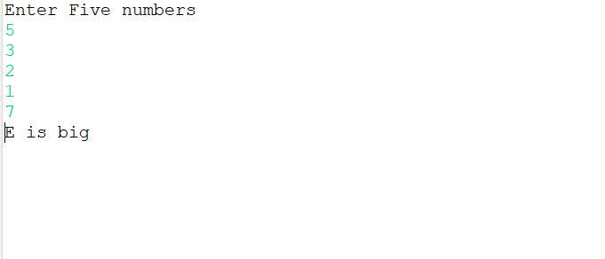

Swap of two variables without using temp.

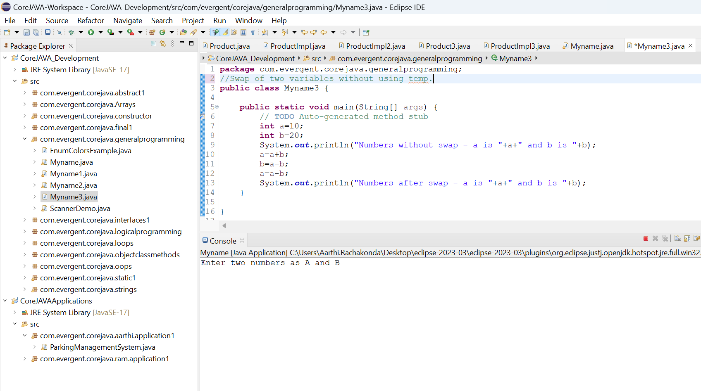

**Date:06/08/2024**

**Day-2**

1. Nested loops

Pattern programs:

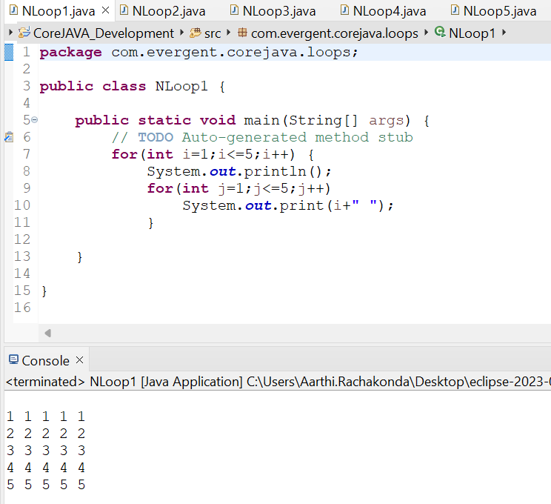

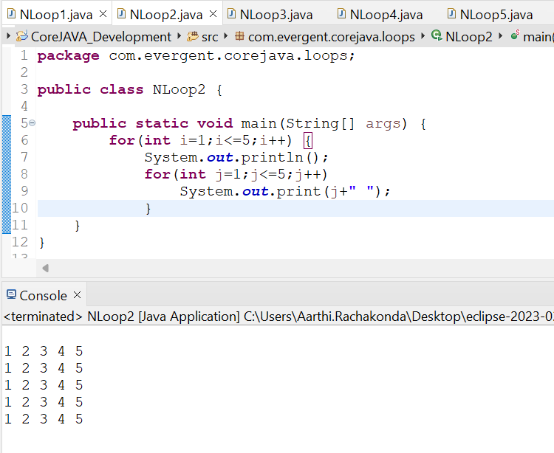

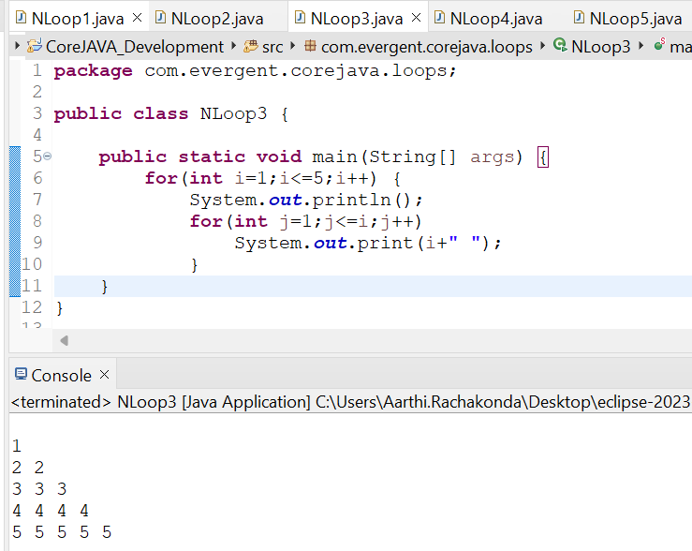

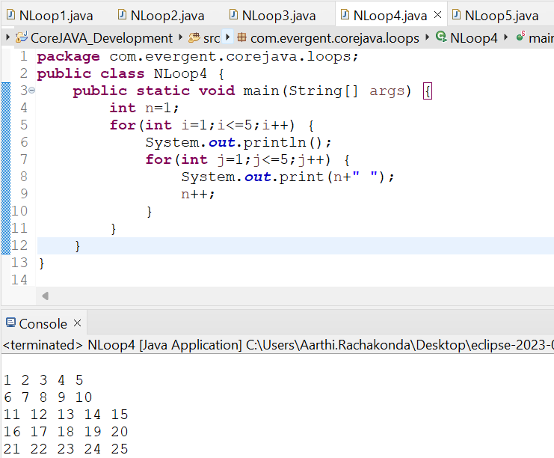

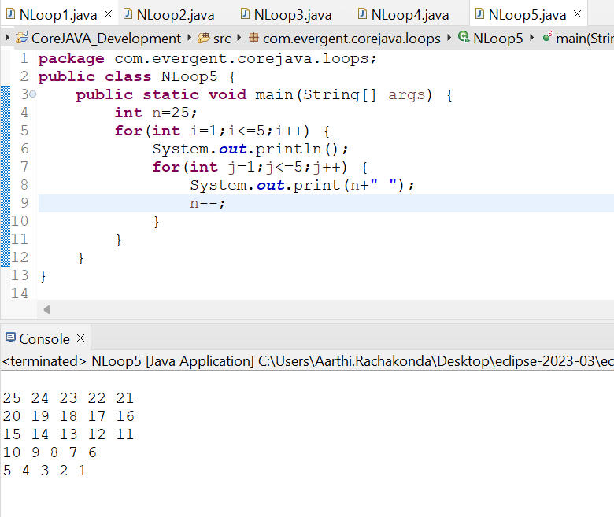

1. **Array**s(collection of Homogenous data types stored in contiguous memory allocation with fixed size.)

a.single dimensional array

b.double dimensional array

3. Fibonacci, Factorial, Swap using temp Programs

4. **Package’s :-**Packages contains classes and interfaces in java

* 1. Pre-defined

1. Java.lang;

* System.stream
* String Class
* StringBuffer

1. StringBuilder
2. Java.util;
3. Java.sql;

**java.lang package:** It is a by default package in Java.

It contains System class, String class, StringBuffer, StringBuilder, Exception classes, Thread class, **Object class**,………

Object class Methods:

1. equals()
2. toString()
3. hashCode()
4. getClass()
5. finalize()
6. clone()
7. wait()
8. notify()
9. notifyAll()

These object class methods are visible for each and every class if you want we can **override** these methods into our class.

* 1. User-defined
     1. The User-defined packages are the those packages which are created by the user explicitly in order to maintain Structure of the Application by placing the similar class into one package
     2. Example:-com.evergent.corejava.arrays;

1. **Switch Case Statement:-**Switch statement in java is a muti-way branch statement.
2. **Scanner Class:-**Scanner Class in java is used to take the input values from the keyboard
3. **Enum:-**enum is a special class that represents the group of constants

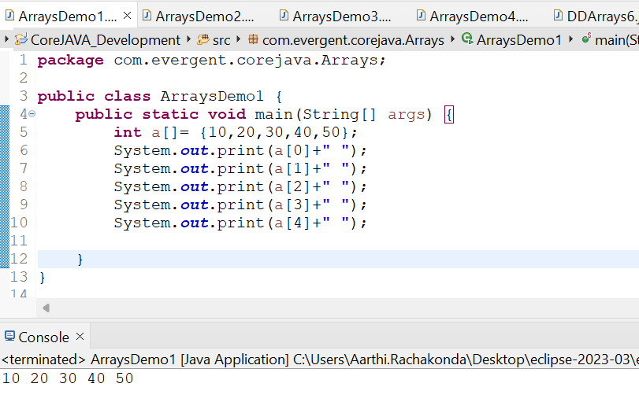 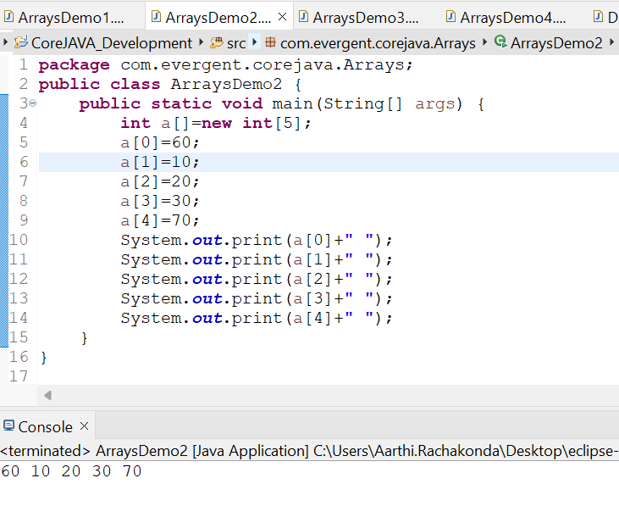

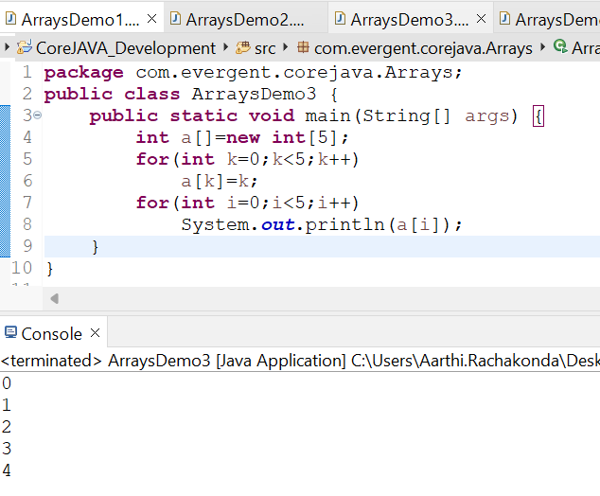

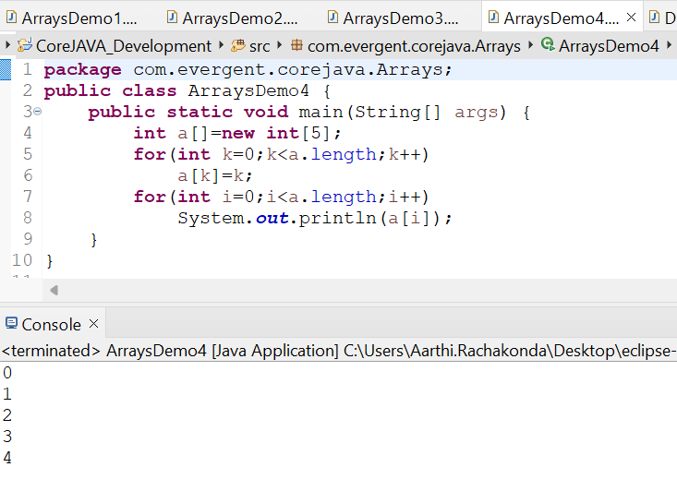

Double dimensional Arrays:

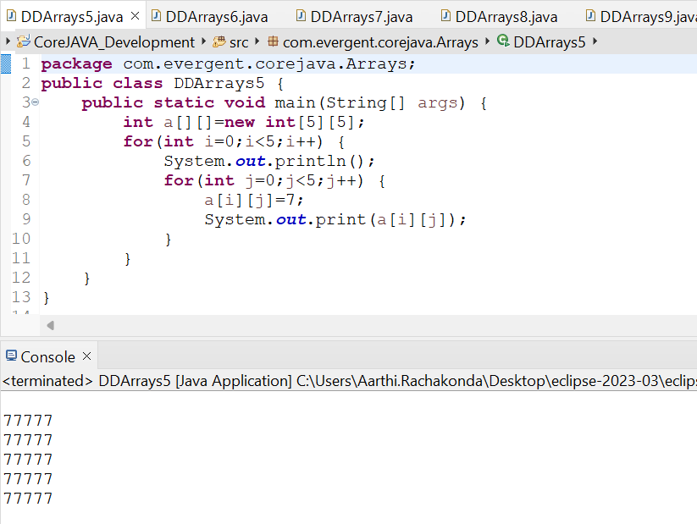

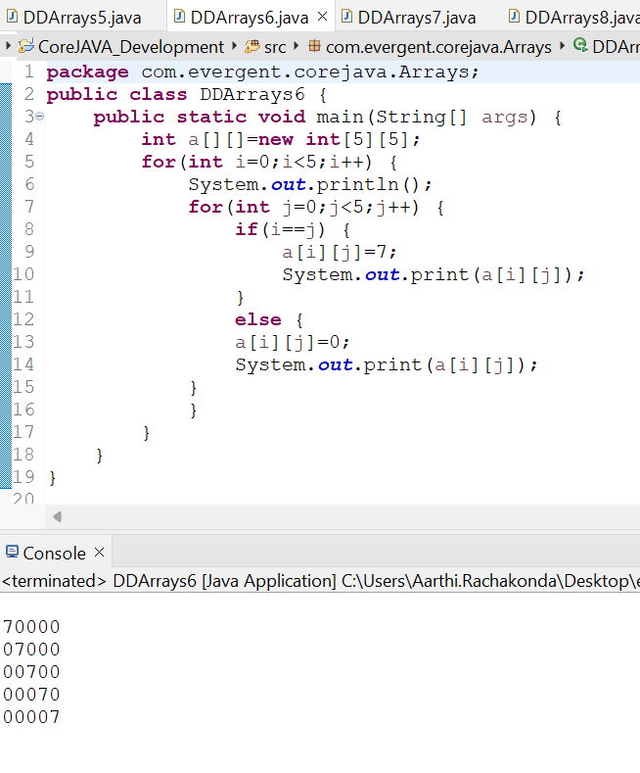

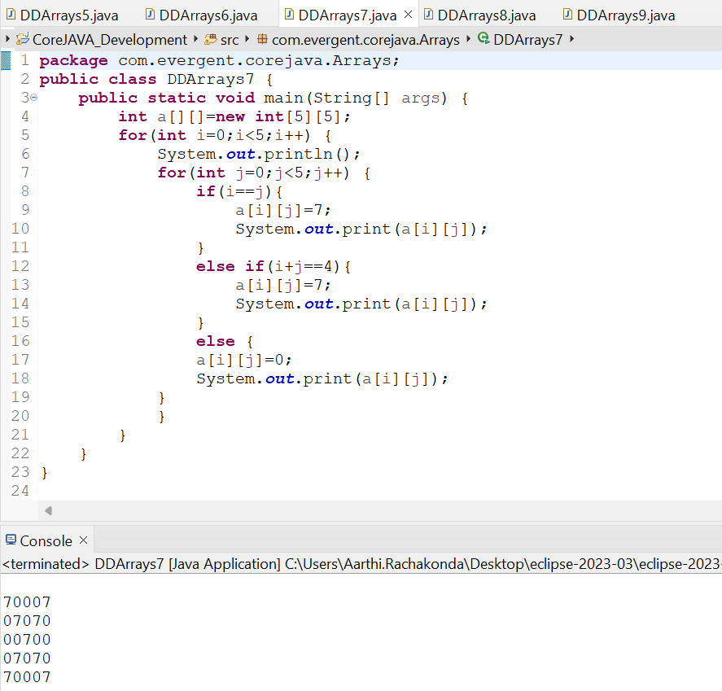

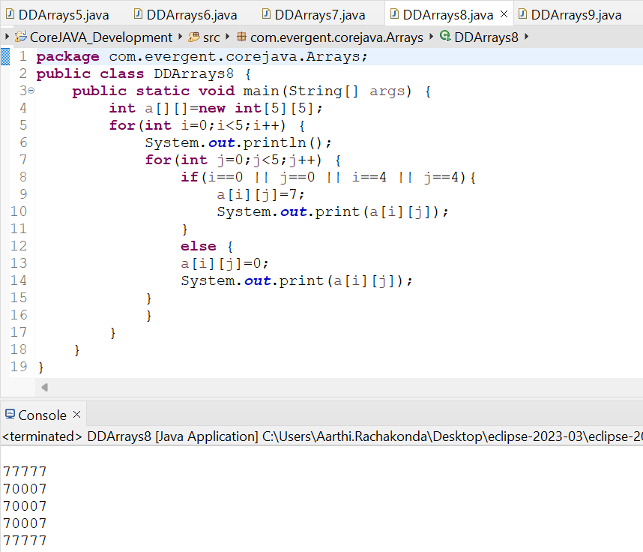

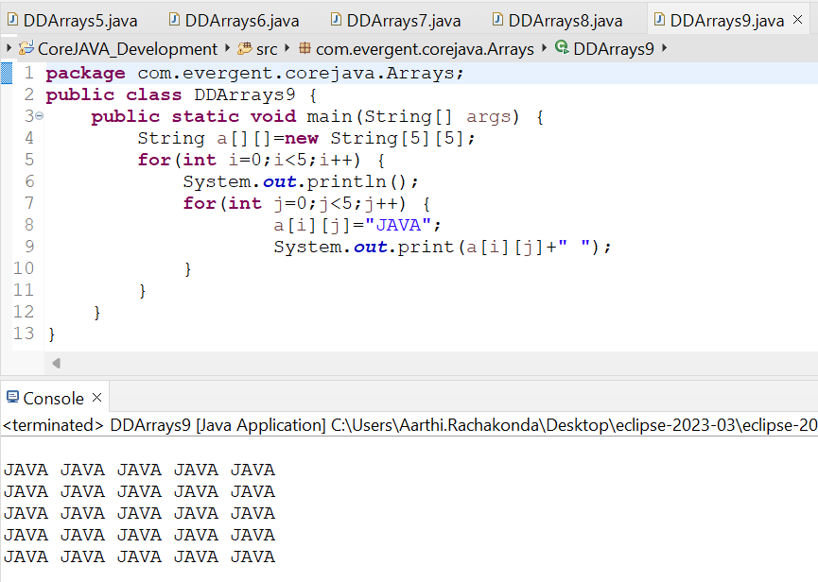

Scanner program:

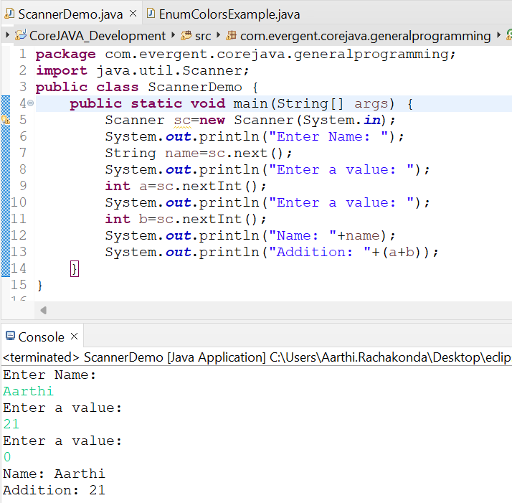

Enum:

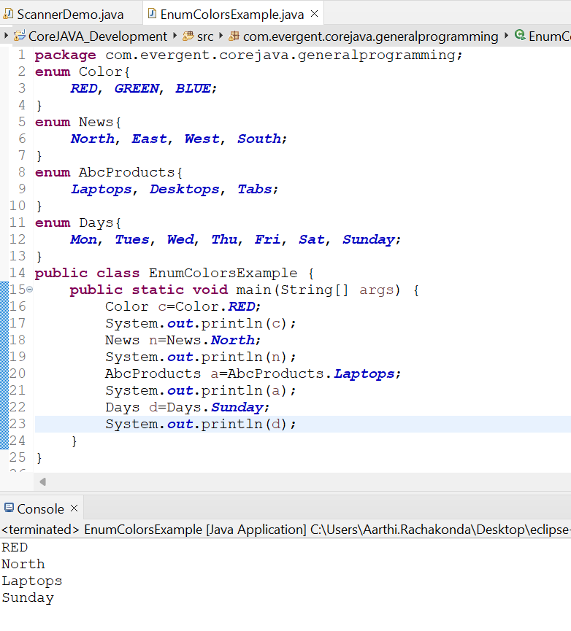

Factorial:

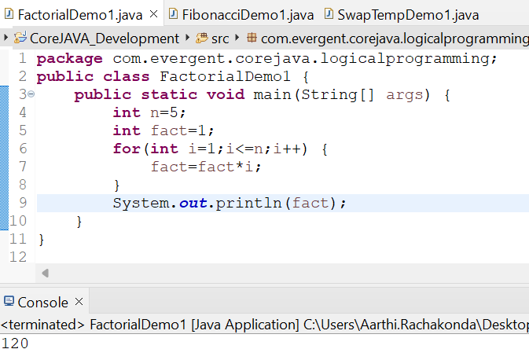

Fibonacci

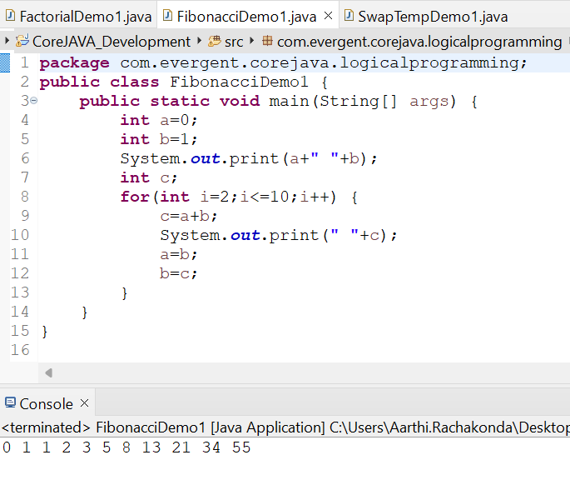

Swap using temp:

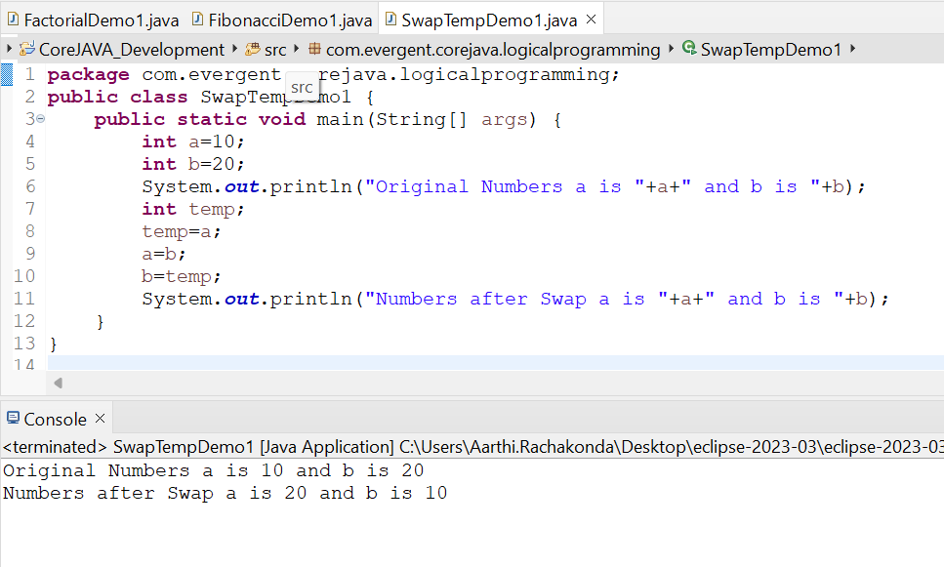

**Date 07/08/2024**

**Day-3**

1. OOPS:Object Oriented Programming Systems. (It is a concept).
2. Encapsulation: It is Mechanism of Binding and methods together inside a class and object creation.
3. Loosely Encapsulation
4. Tightly Encapsulation
5. Method Flow - 4 Different ways.
6. No Parameters with no return type
7. Parameters with no return type
8. Parameters with return type
9. No Parameters with return type
10. Inheritance: Reusability of existing functionalities from super class to subclass.
11. Polymorphism: Many Forms.
12. Compile Time Polymorphism - method overloading.(same method names, different parameters, return type may or maynot be same. It will happen in same class or different class. )
13. Run Time Polymorphism - method overriding.(Method names are same, Parameters are also same, return type also same. It will happen in two different classes or interfaces through inheritance.)
14. Abstraction : Hiding Implementation details and showing functionalities.
15. IS-A (for Inheritance) and HAS-A(Through object creation) relations.
16. System.out.println statement.

Encapsulation:

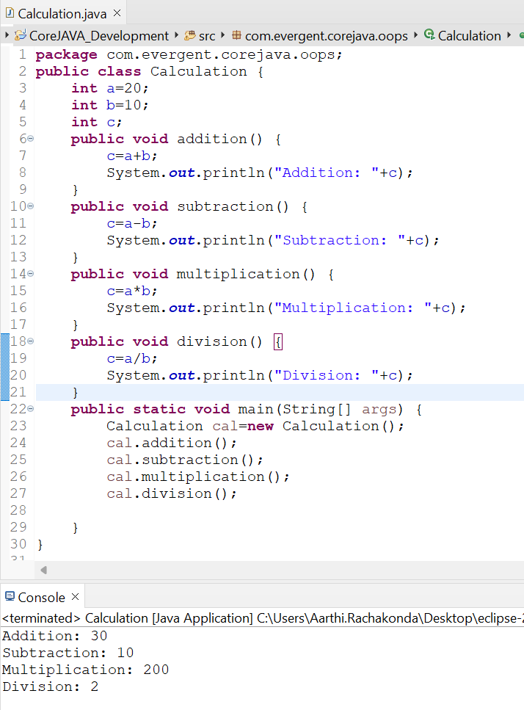

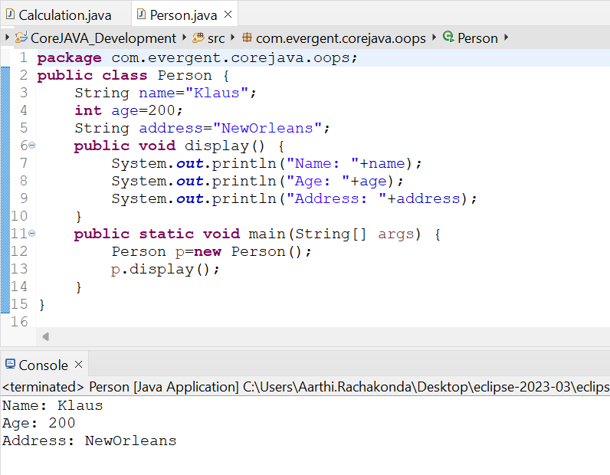

Method flow:

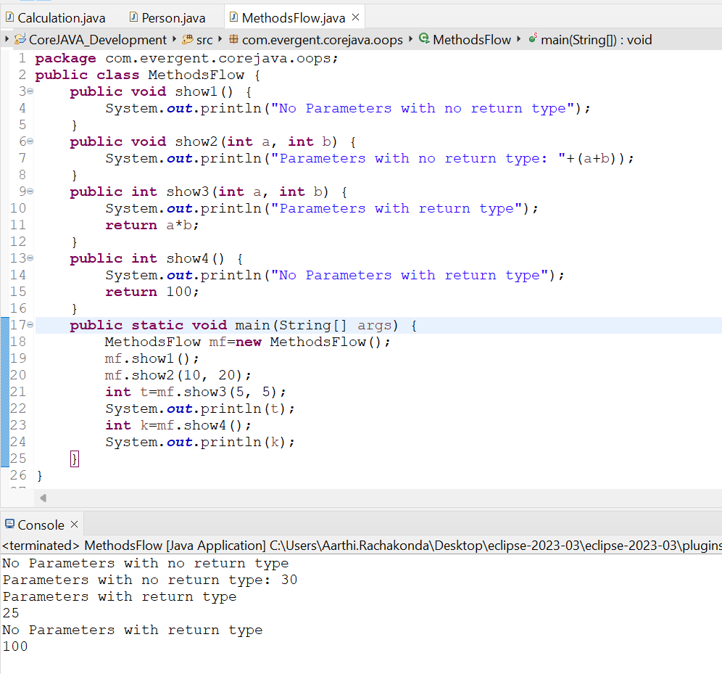

Inheritance

Java won’t support multiple inheritance through classes.

Java will support multiple inheritance through interfaces.

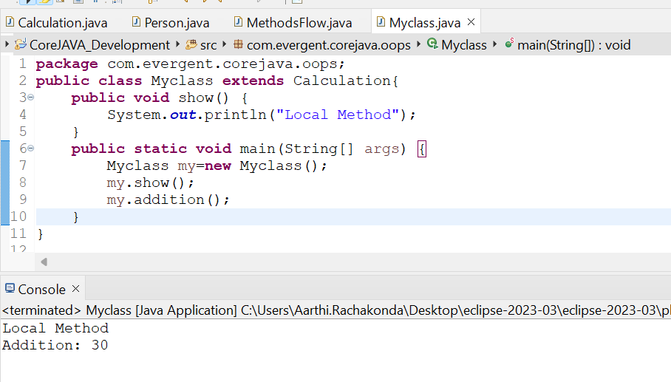

Multilevel Inheritance:

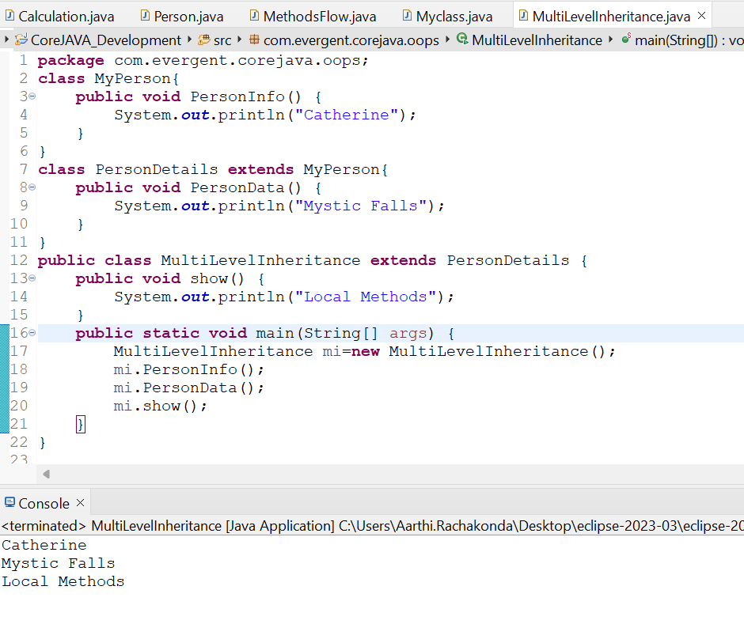

Overloading:

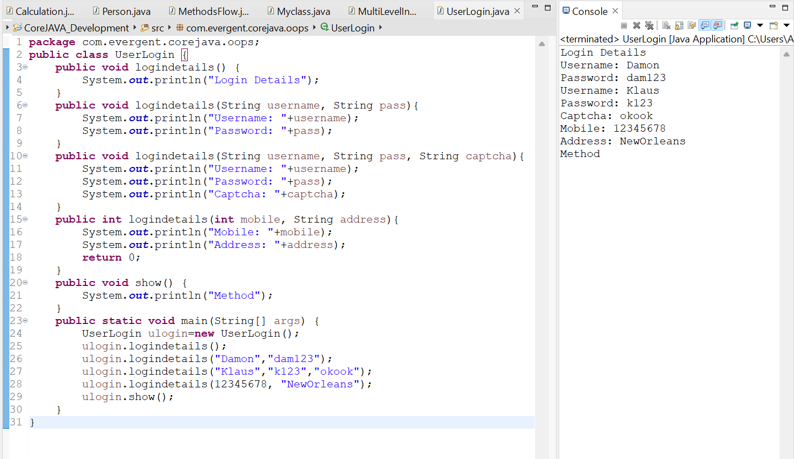

Overriding:

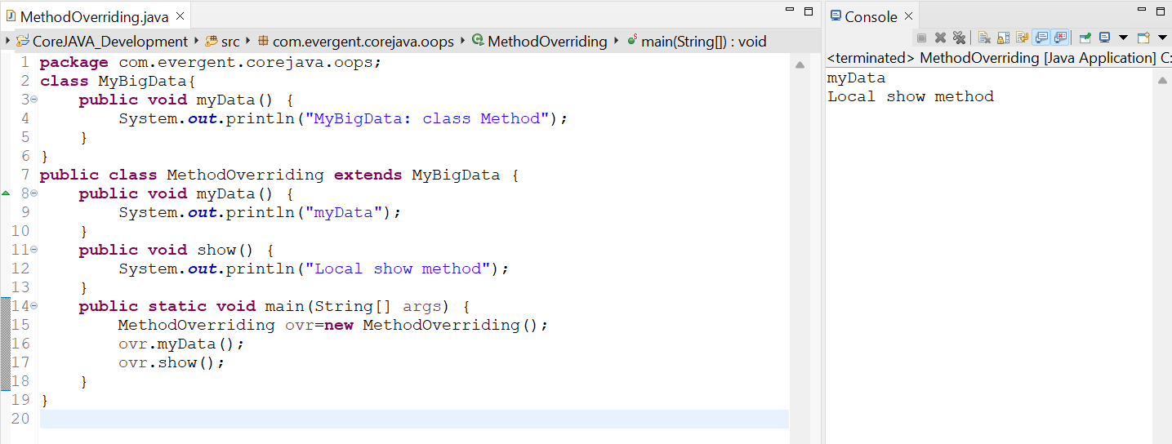

HAS-A Relation:

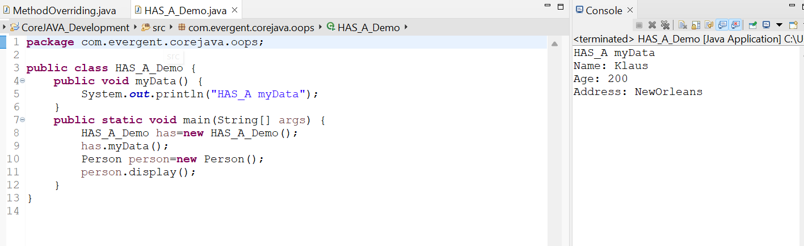

**Date 08/08/2024**

**Day-4**

**Constructor:**

1. Class Name and Constructor name should be same.
2. There are two types of constructors
3. Default Constructor.
4. Parameterized Constructor.
5. We can access constructor while creation of objects.
6. Constructors are mainly for initializing.
7. Constructors does not have any return type, not even void also. If we declare as a void it will consider as a method not a constructor.
8. Every class needs atleast one default constructor. Either you will create or compiler will generate.
9. This, super keyword
10. This - We can call one constructor to other constructor through ‘this’ keyword within a class.
11. Super - It always will call super class constructor.
12. Always constructors are overloaded.
13. We can call one constructor to other constructor through ‘this’ keyword within the class.
14. Object copy Constructor.
15. We can initialize values to default constructor.

Methods are needed to be called explicitly by object reference.

Constructors are called implicity when the object is created.

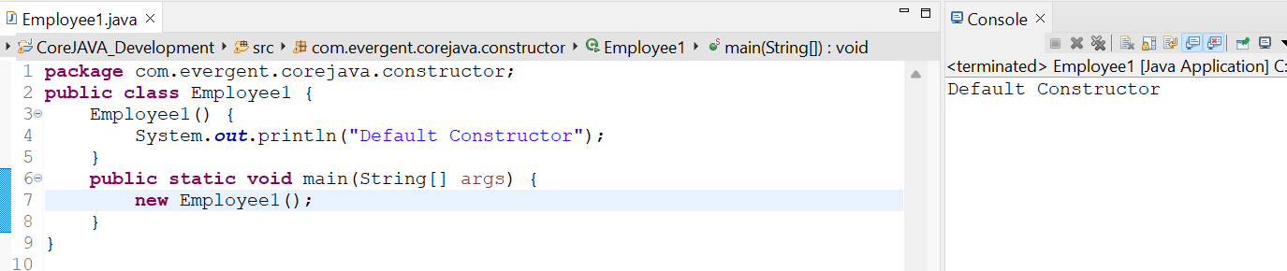

#### 

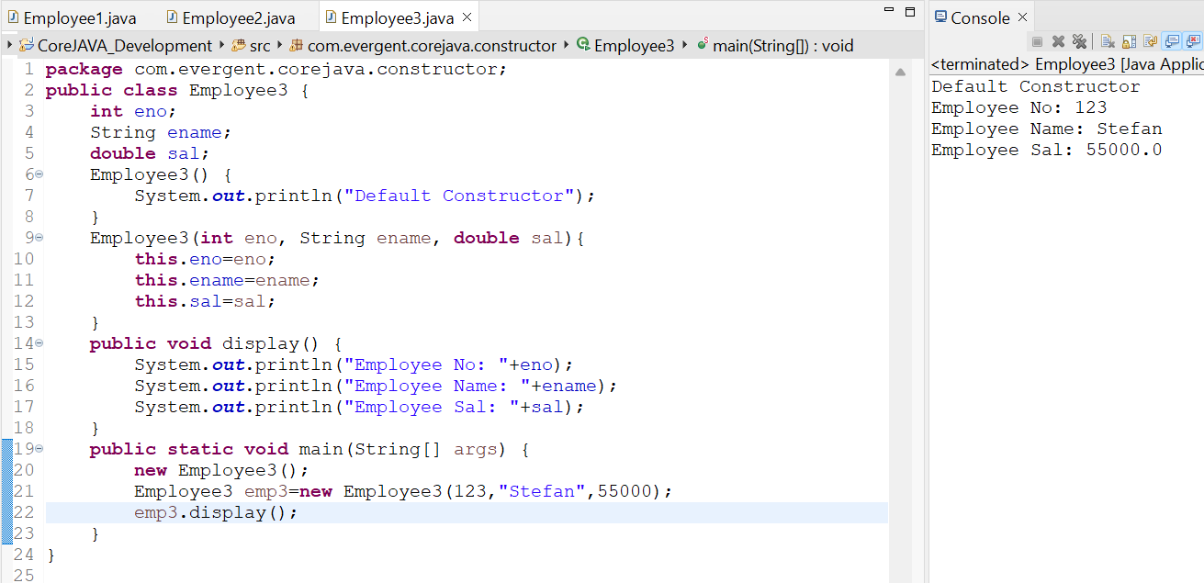

Method vs constructor:

Methods are needed to be called explicitly by object reference.

Constructors are called implicity when the object is created.

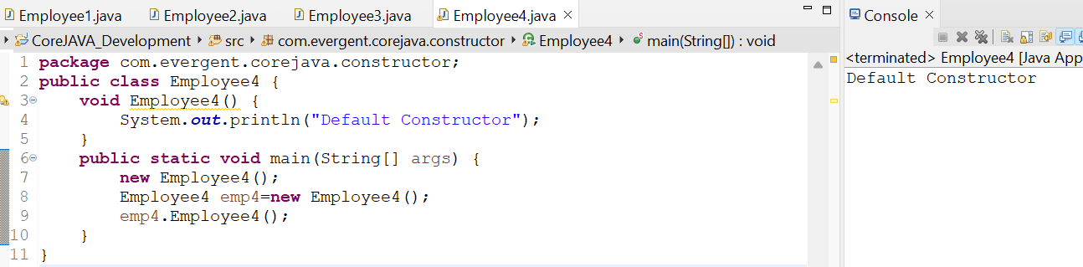

This keyword:

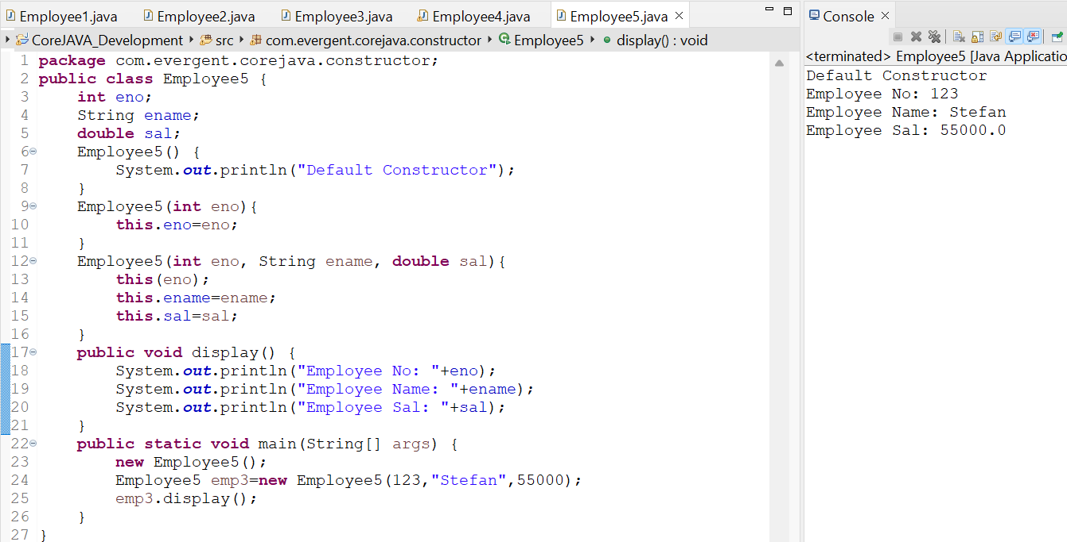

Super keyword:

Constructor chaining

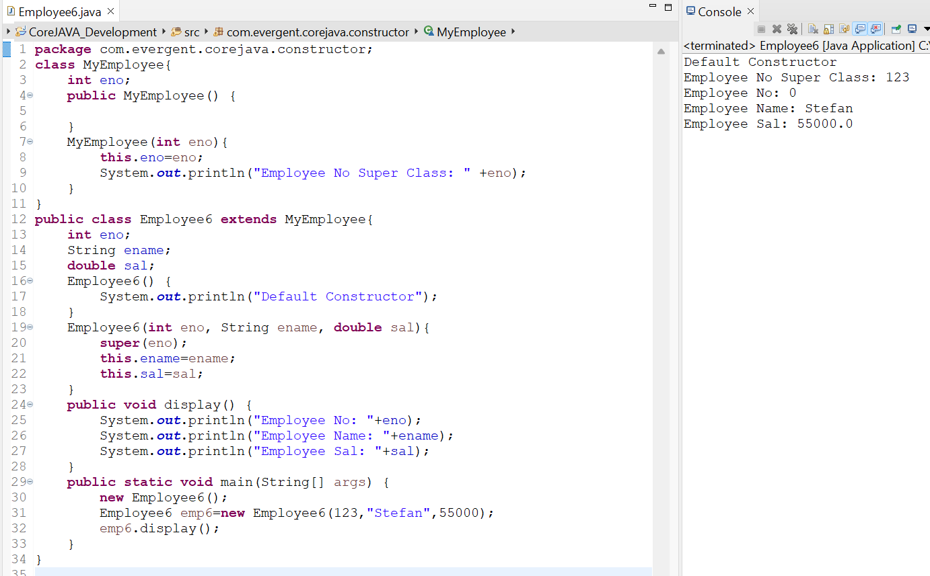

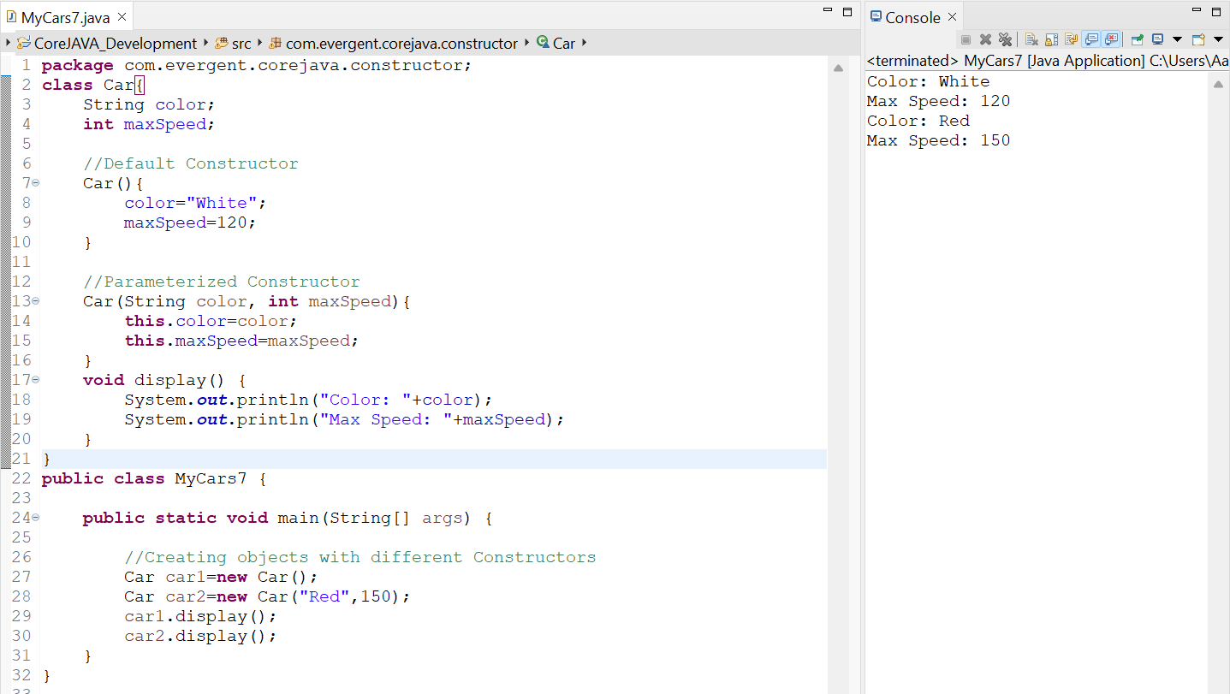

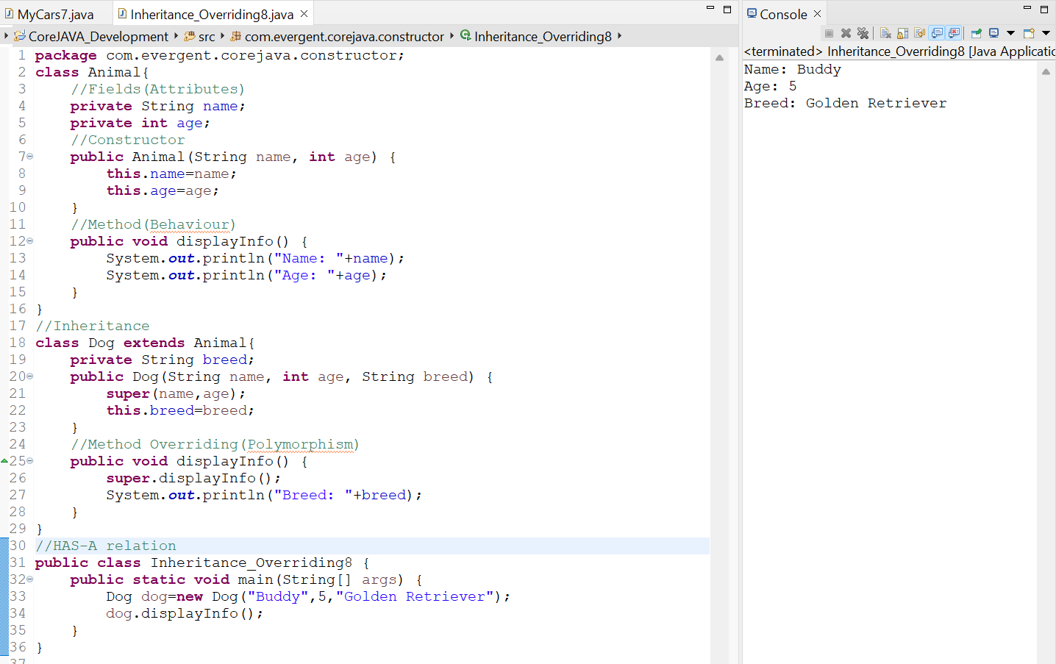

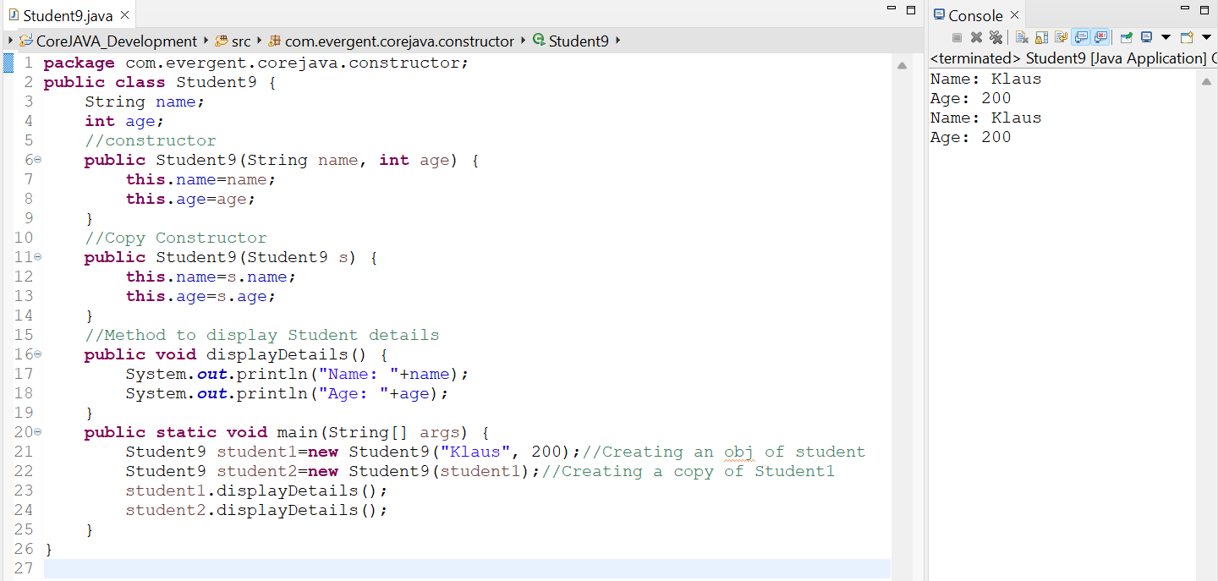

**Date 09/08/2024**

**Day-5**

**STATIC**:

1. static is a Keyword.
2. We can declare static as variables, methods.
3. We can access static variables and methods direct through classname.methodname, classname.variablename.
4. Static methods can access static methods & static variables only.
5. Static methods cannot access non static methods and non static variables.
6. Non-static method can access static variables and static methods.
7. Static Block.

Static block is executed automatically without calling the block in the main method.static block is compiled during the execution of class.At first static block is executed then remaining main method,classes,etc will be executed.

**FINAL:**

1. Final is a keyword.
2. We can declare final as variables, methods and classes.
3. We cannot modify the value of final variable.
4. We cannot override the final method.
5. Final class cannot be inherited.

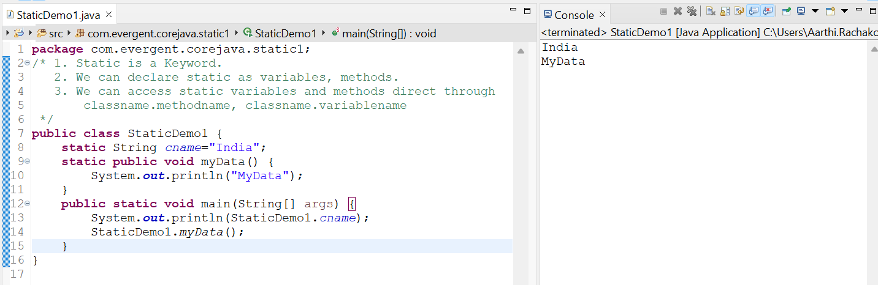

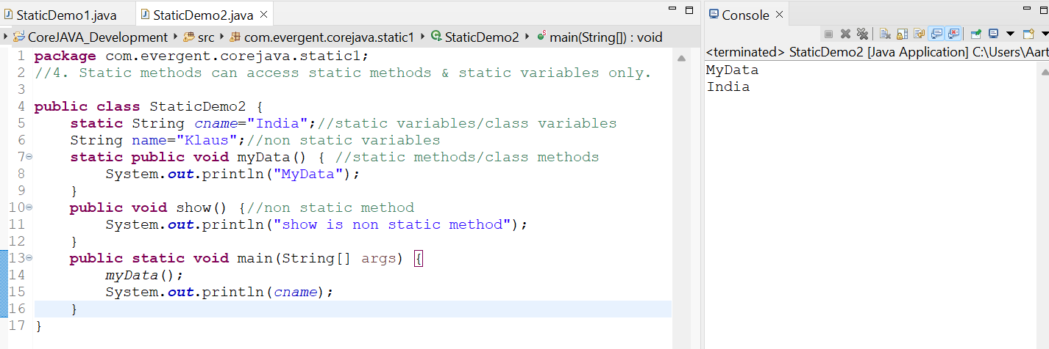

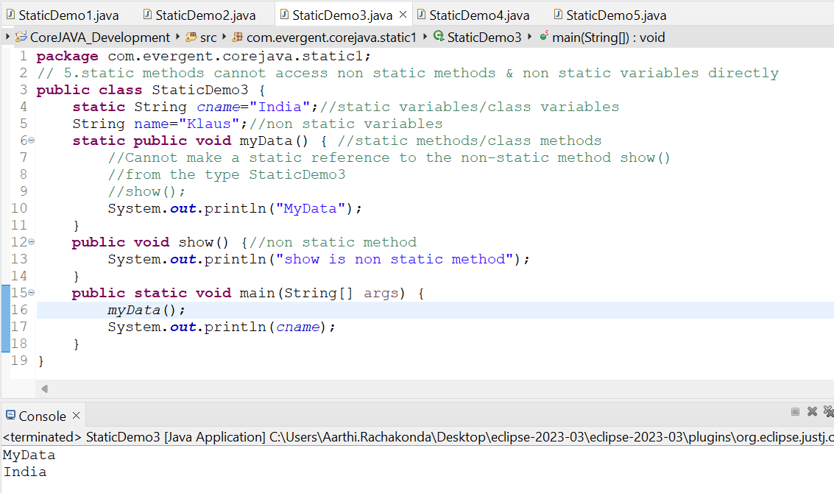

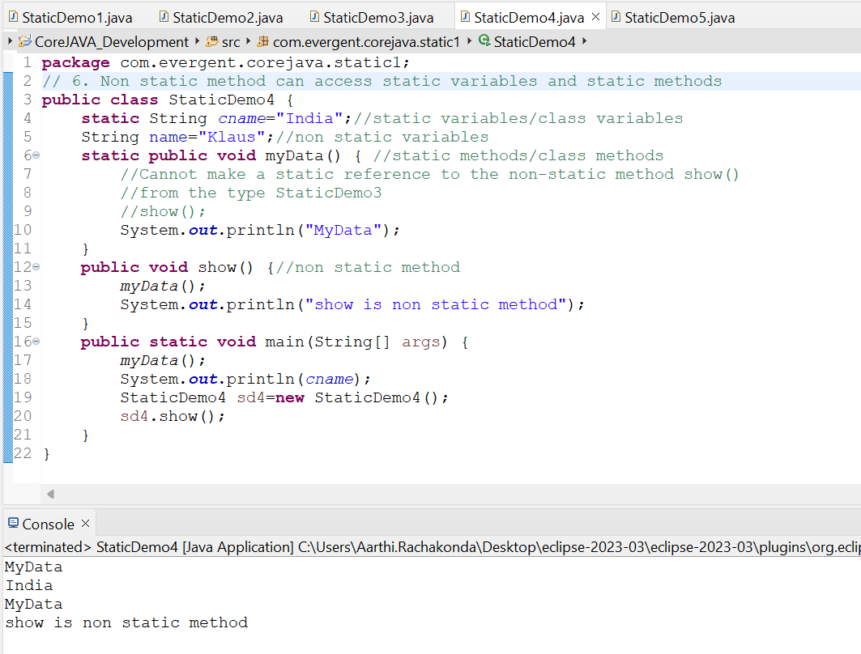

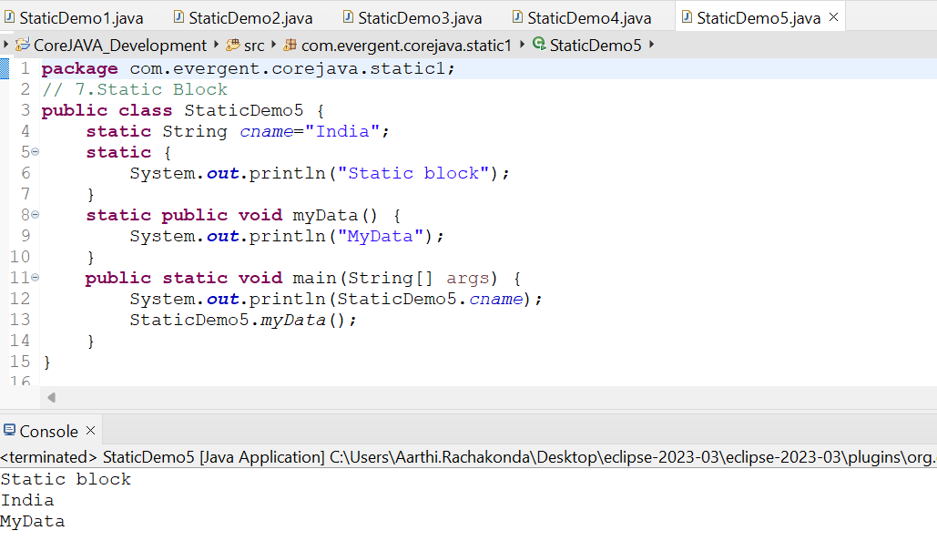

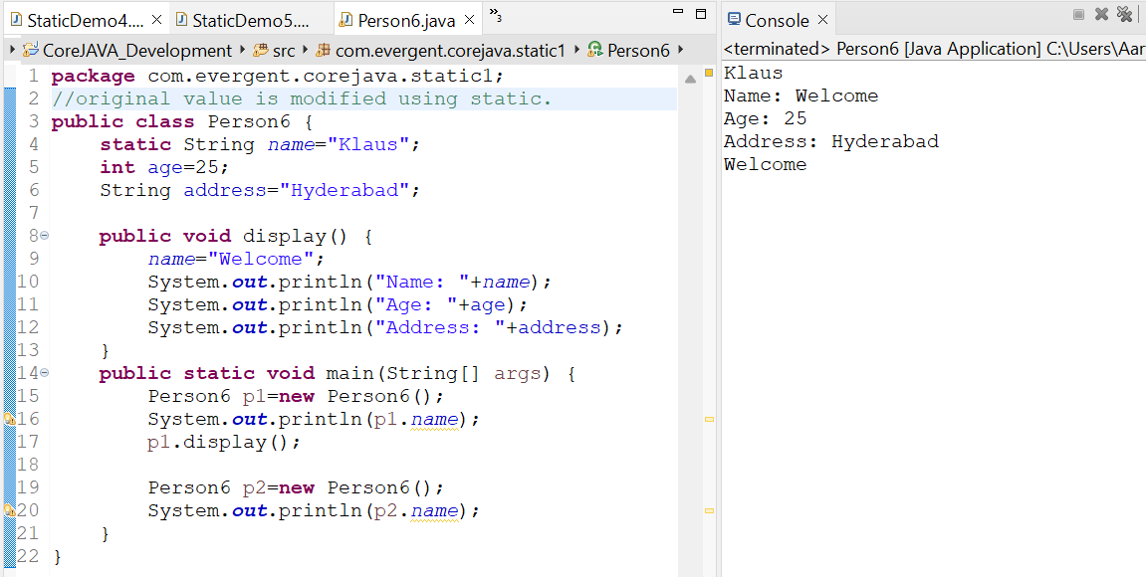

Final:

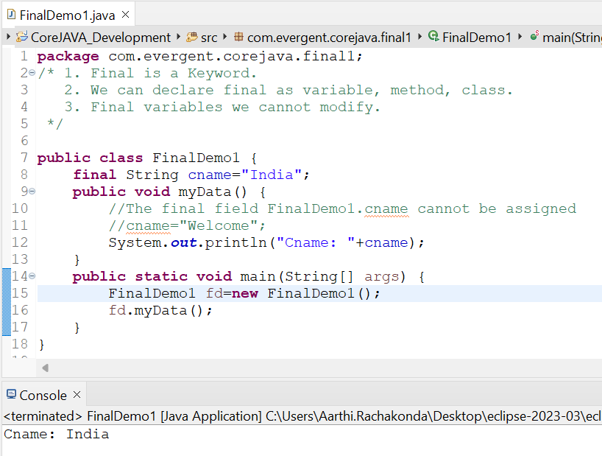

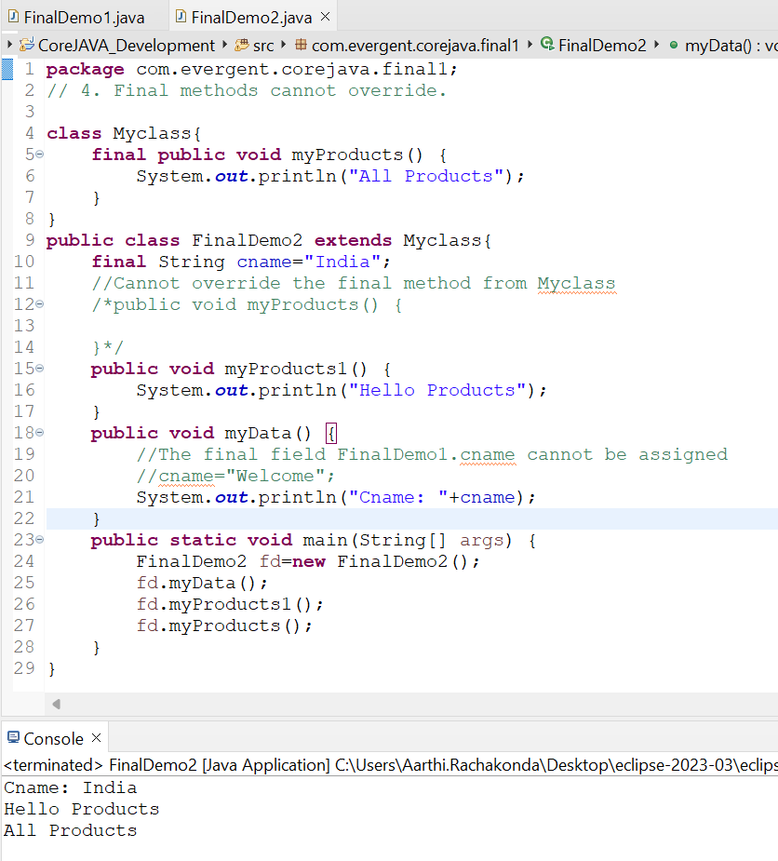

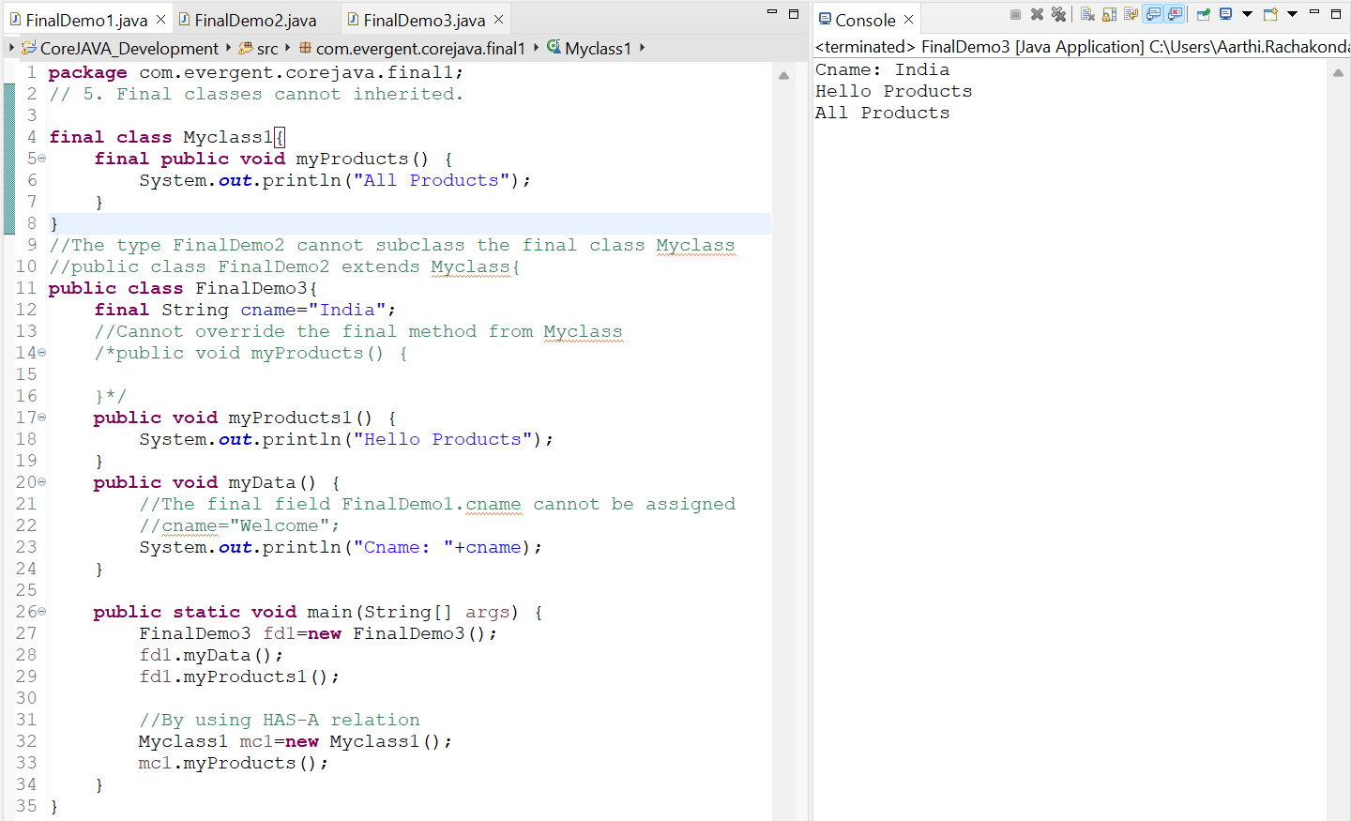

**Date 12/08/2024**

**Day-6**

**STRINGS:**

1. In Java, a String is a sequence of characters, often used to represent text.
2. Strings are objects in Java and are instances of the String class, which is part of the java.lang package.
3. Key Features of Strings in Java:

**Immutable:** Once a String object is created, it cannot be changed. Any modifications to a string creates a new string object.

1. Java optimizes memory usage by storing strings in a special area of memory known as “String Pool”.
2. If two Strings have the same value and are created without using the new keyword, they will refernce the same object in the string pool.
3. We can create a string in Java in multiple ways:
4. Using String literals: String str = “Hello, World!”;
5. Using the new keyword:

String str = new String( “Hello, World!”);

|  |  |  |
| --- | --- | --- |
| String | StringBuffer | StringBuilder |
| Is a final class(can’t extend) | Is a final class(can’t extend) | Is a final class(can’t extend) |
| Immutable(can’t modify) | Mutable(can modify) | Mutable(can modify) |
| Methods in String class are non-synchronized(not-thread safe) | Methods in StringBuffer class are synchronized(thread safe) | Methods in StringBuilder class are non-synchronized(not-thread safe) |
| Strings are used for Single update | StringBuffer is not recommended as it has legacy API | StringBuilder are used for multiple updates.It is started from JDK 1.5 |

String creation:

We can create String in two ways

1. Using new keyword.(Object is created for every new keyword even though the same data is present in the heap area)
2. Using String literal.(Object is created if and only if the keyword is not present in the String Constant pool.)

String str1=new String(“JAVA”);

String str2=new String(“JAVA”);

String s1=”JAVA”;

String s2=”JAVA”;

String constant pool

JAVA

JAVA

JAVA

String class

* String is a final class.
* Strings are immutable.
* String class consists of methods.
* Methods in String class are non-synchronized.
* equals() in String used to check the content.
* == method in String is used to check the Memory location.
* String methods :
* toLowerCase()-Changes the complete String into lowercase
* toUpperCase()-Converts the complete String into uppercase
* length()-To know the length of the String,
* trim()-To remove the spaces before the String)
* contains()-to check whether the substring is present in the string
* replace()-to replace the values with other values
* reverse()-to reverse of the String
* concat()-to combine two strings into one String

**StringBuffer**

* StringBuffer is a final class.
* StringBuffers are mutable.
* It consists of methods.
* Methods in StringBuffer class are synchronized.

**StringBuilder**

* String Builder is a final class.
* StringBuilder are mutable.
* StringBuilder class consists of methods.
* Methods in String class are non-synchronized.

Legacy API (not recommended to use)

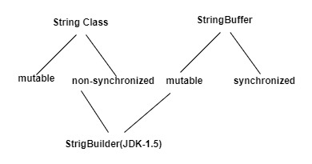

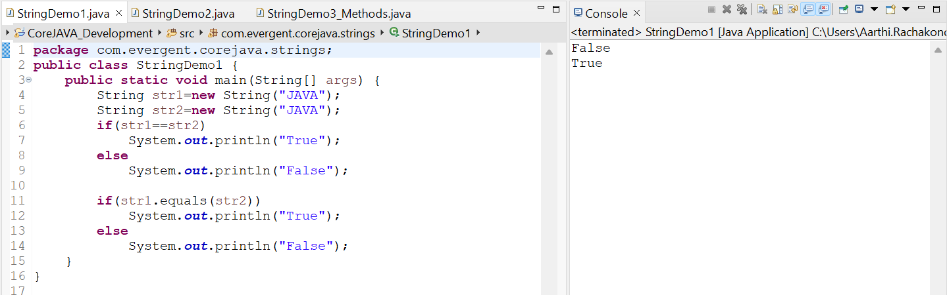

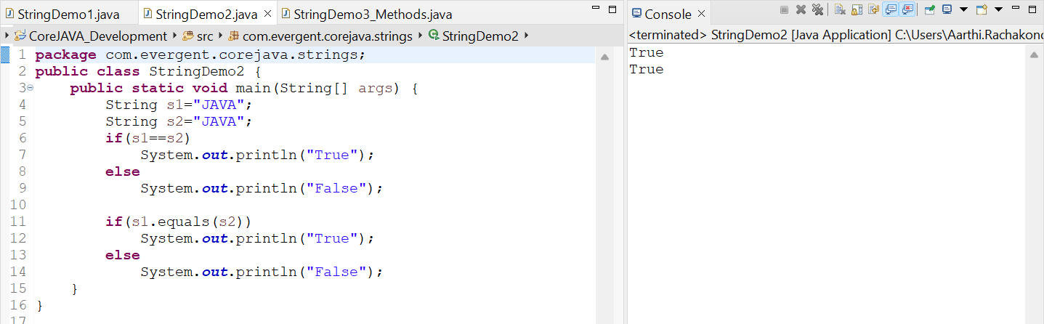

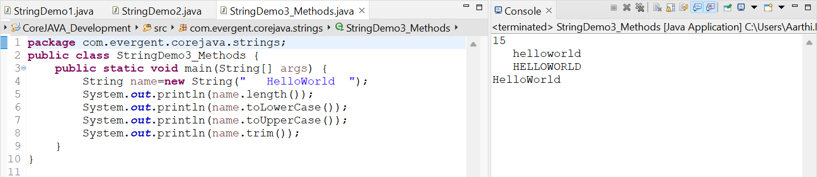

Create a java program that creates a string, checks if it contains a specific substring, & then print out the result.

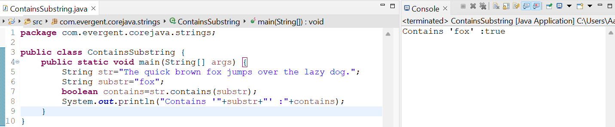

Write a java program to create a string, remove all spaces from the string, then print out the result.

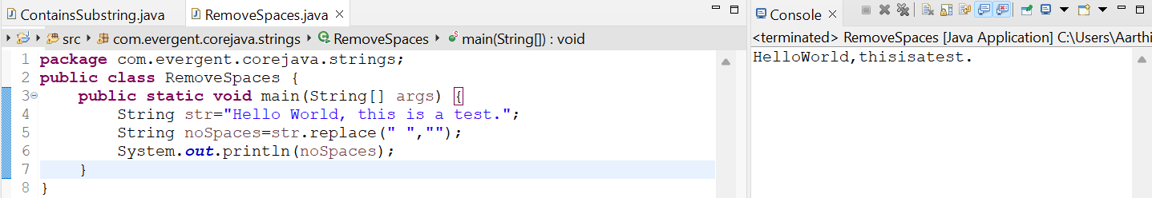

Write a java program to create a string, reverse the order of its characters, and then print out the result.

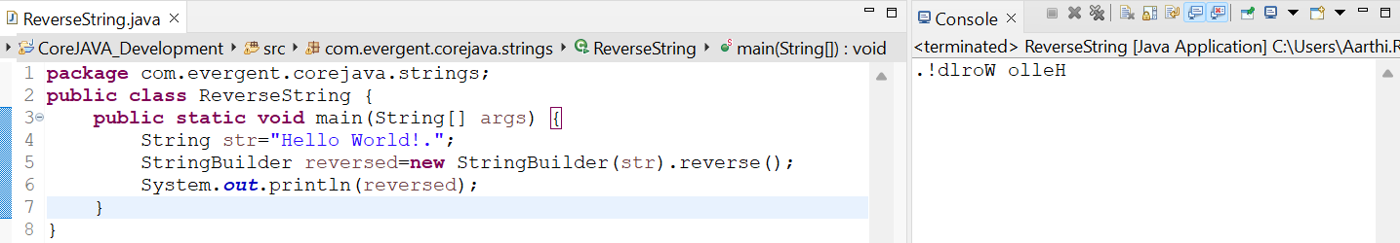

Concatenation:

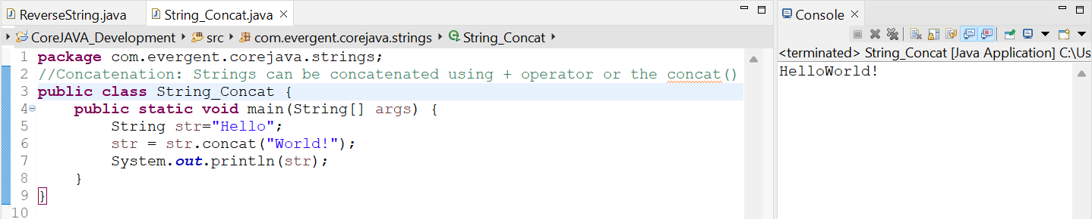

StringBuffer:

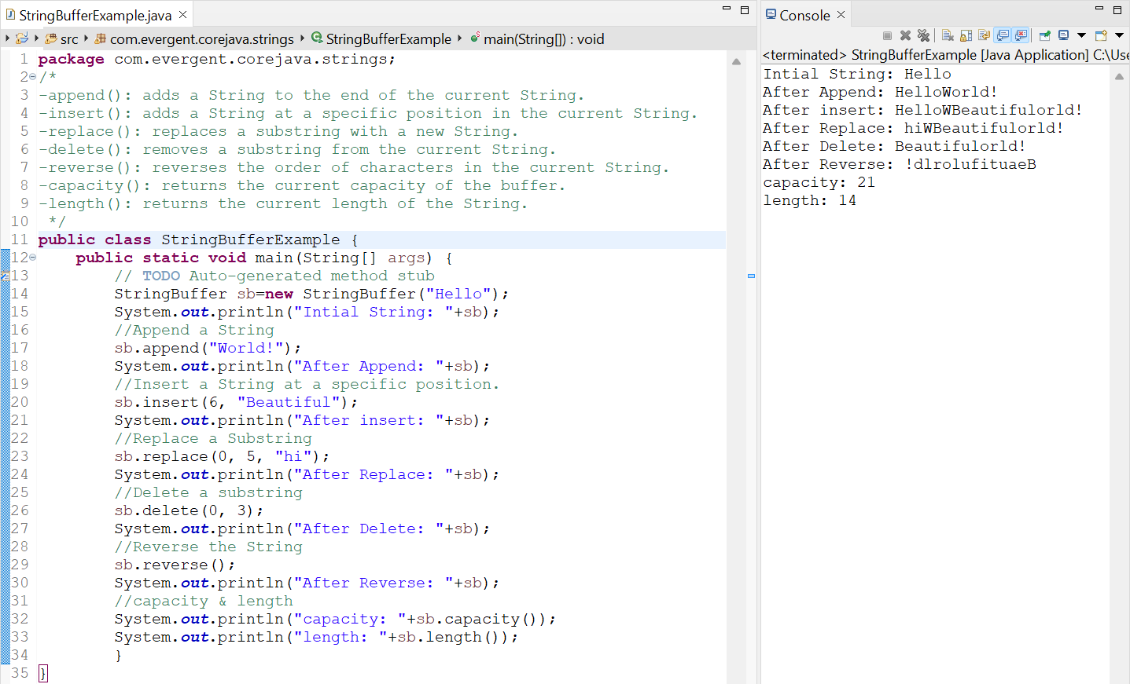

StringBuilder:

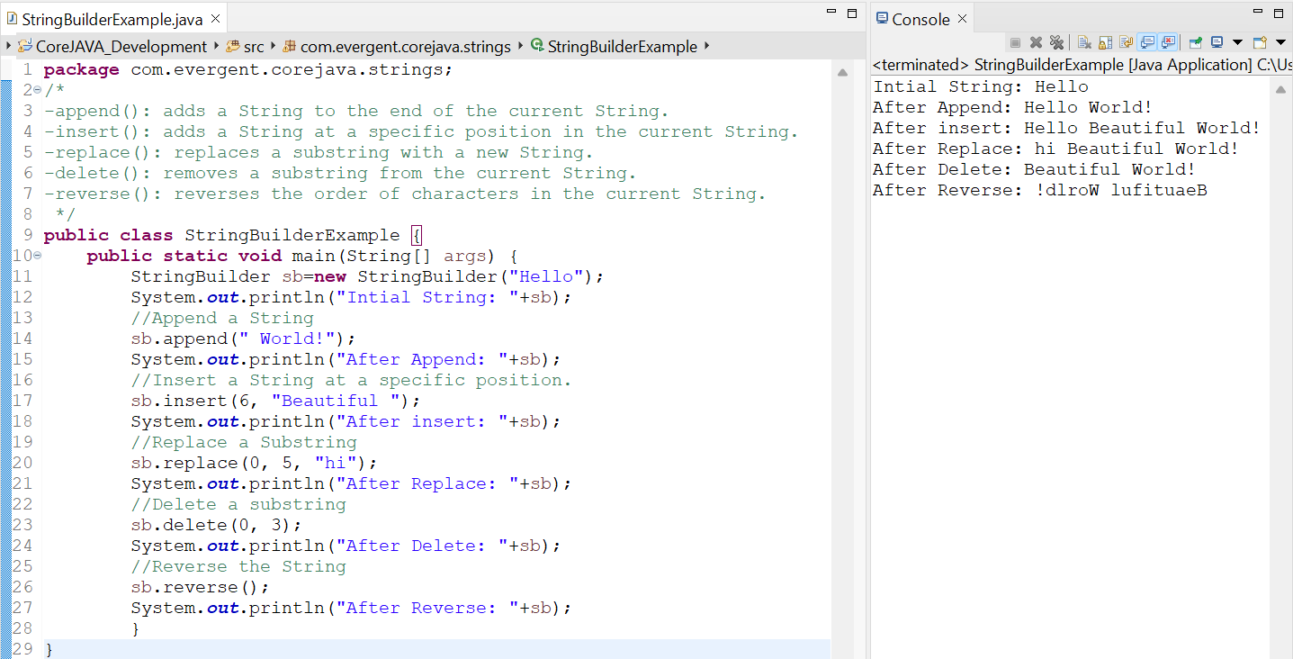

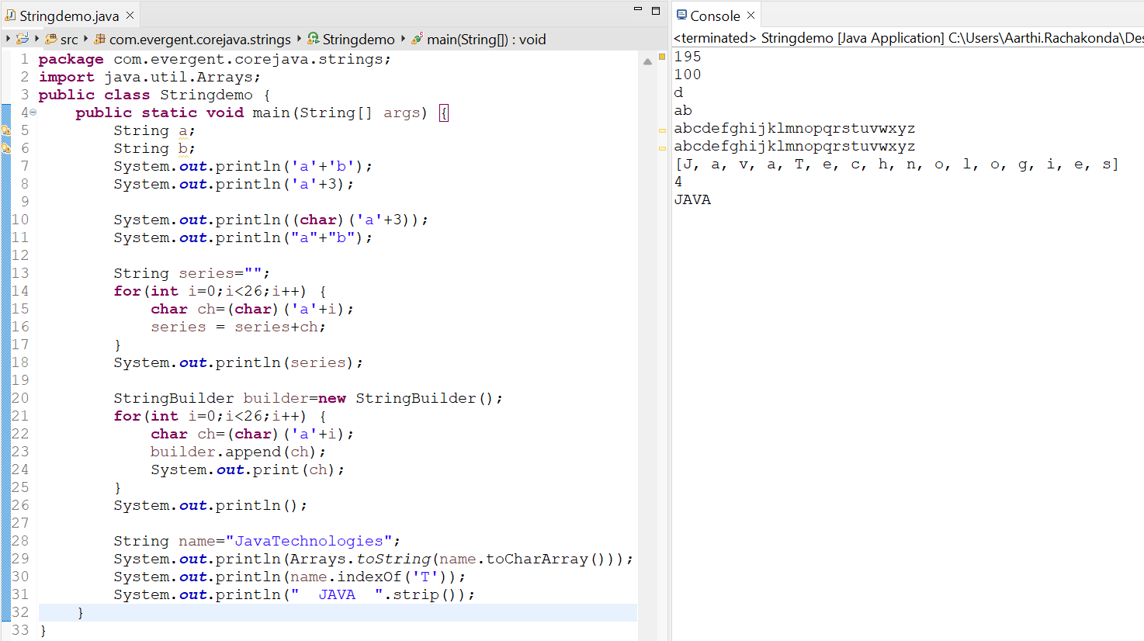

**Date 13/08/2024**

**Day-7**

**Creating our own Immutable class:**

1. We can declare class as final.
2. The class is declared as final so that it cannot be subclassed.

Private Final Fields:

The fields name and age are private and final.

Constructor:

The Constructor initializes the final fields when a person object is created.

**Interface:**

1. Interface is a Keyword.
2. We can declare method signature only but not implementation.
3. By default all interface methods are abstract.
4. If any class implements interface that class should be override all interface methods otherwise, that class will be showing compile time error.
5. We cannot create object to interface but we can create reference to interface.
6. We can declare variables inside interface. All interface variables are by default public, static and final.
7. Java will support Multiple Inheritance through interface.
8. One class can implement interfaces.
9. One Interface can extend other interfaces.
10. Marker Interface: We can declare interfaces without methods (or) Zero interfaces.

MARKER INTERFACE:

Clonable interface

Serilizable interface

1. We can achieve complete abstraction through interfaces.

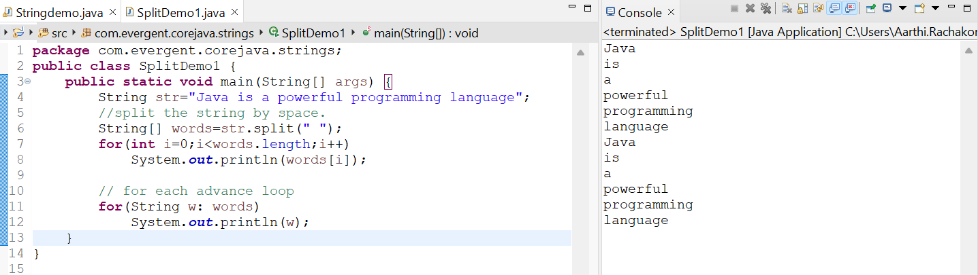

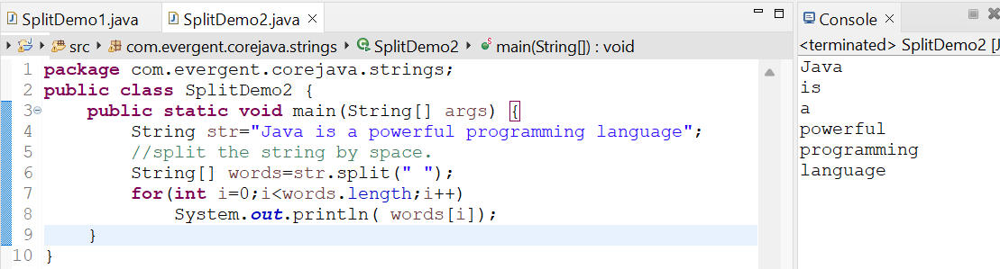

We can create our own immutable class.

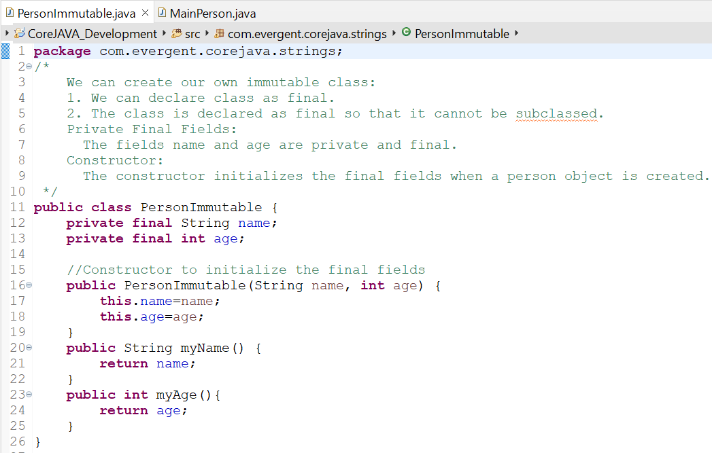

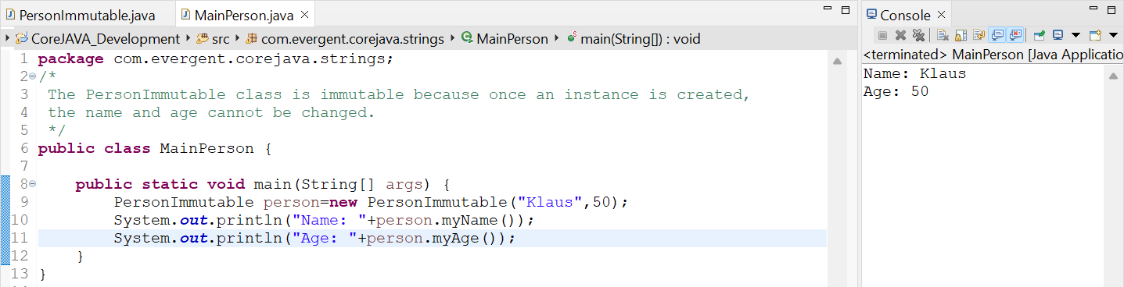

Object class method:

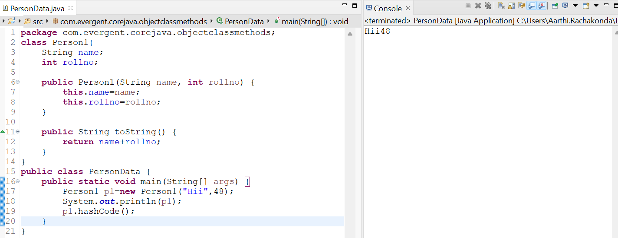

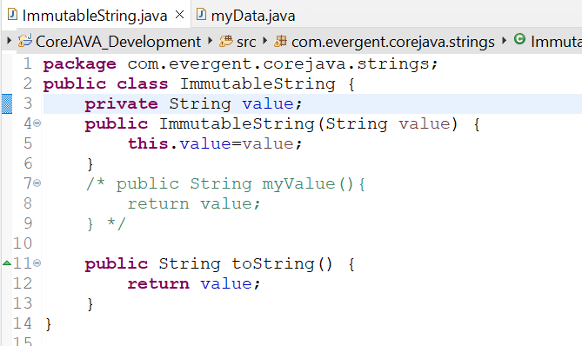

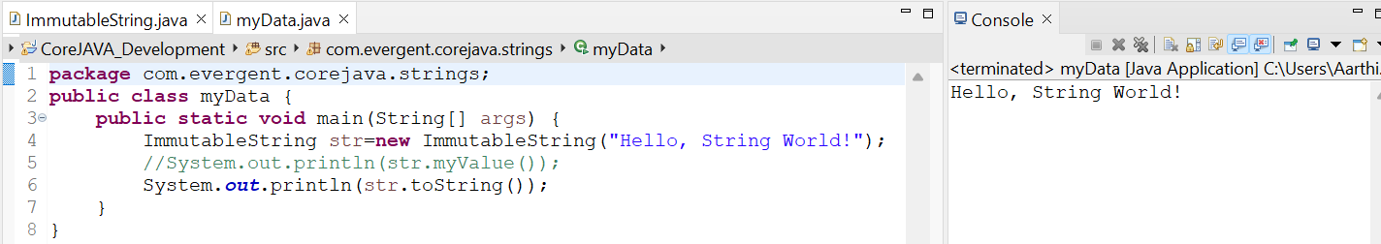

Interfaces:

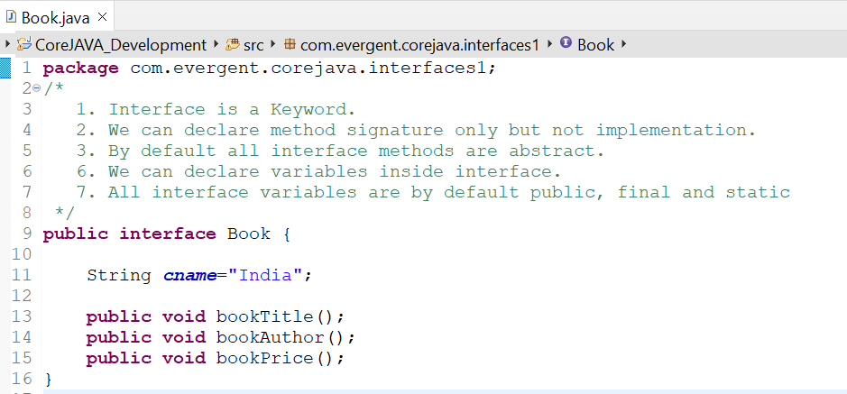

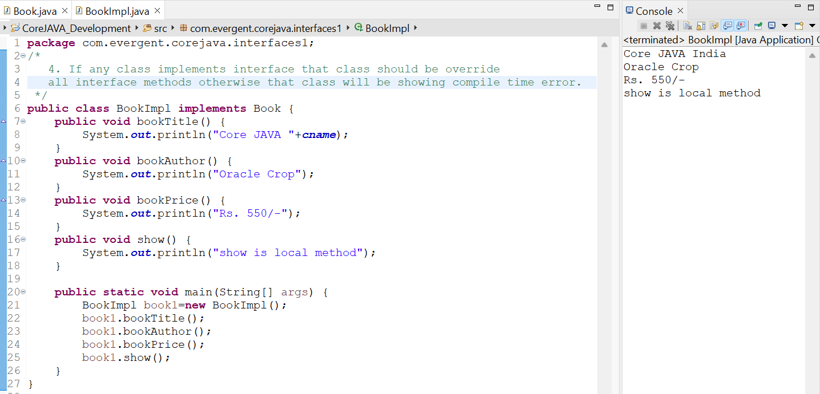

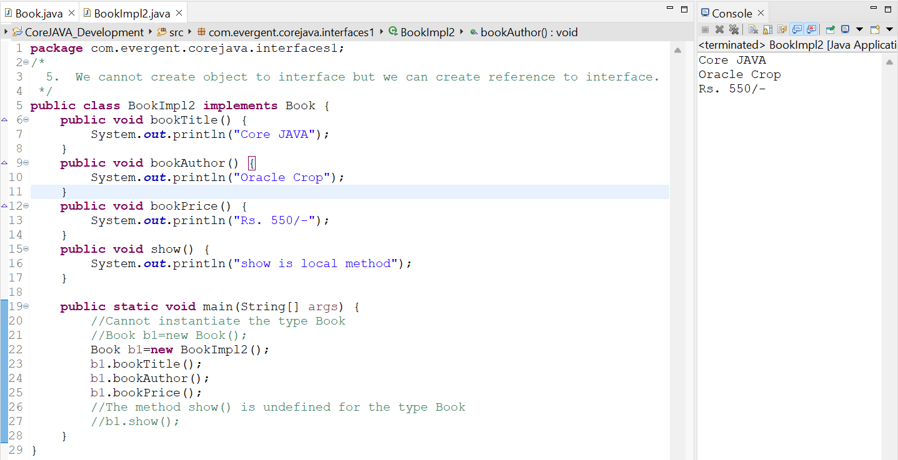

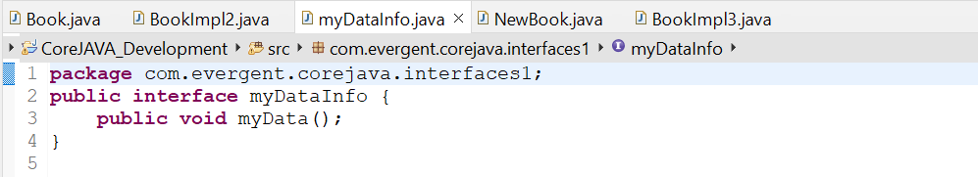

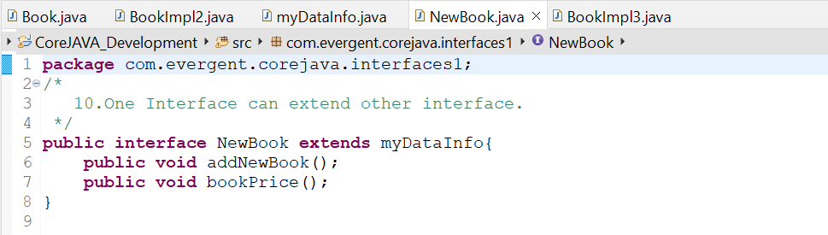

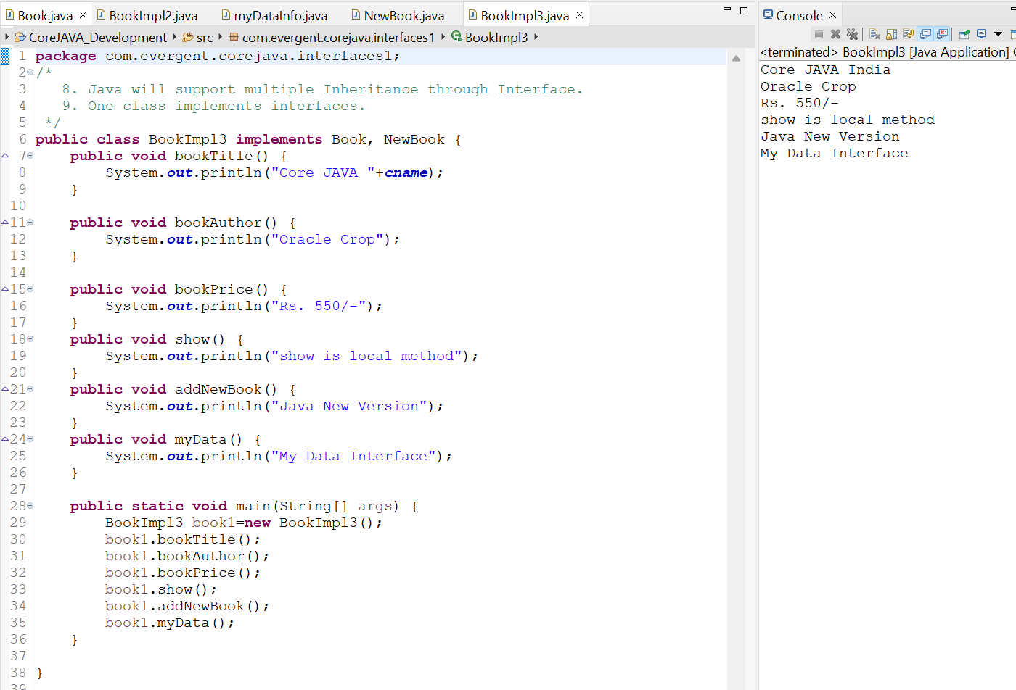

**Date 14/08/2024**

**Day-8**

* **Abstract Class:**

1. Abstract is a Keyword.
2. Abstract class having abstract methods and concrete methods ( implementation methods ).
3. If any class having one abstract method that class should be declared as a abstract keyword otherwise that class will be showing compile time error.
4. If any class extends abstract class that class should be override all abstract methods otherwise that class will be showing compile time error.
5. We cannot create object to abstract class but we can create reference to abstract class.
6. We can create constructor to abstract class.
7. We can access abstract class constructor through subclass object creation.

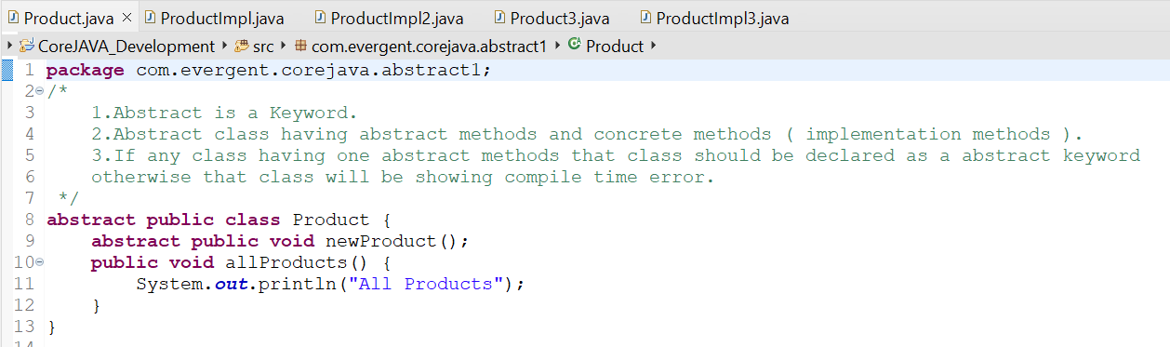

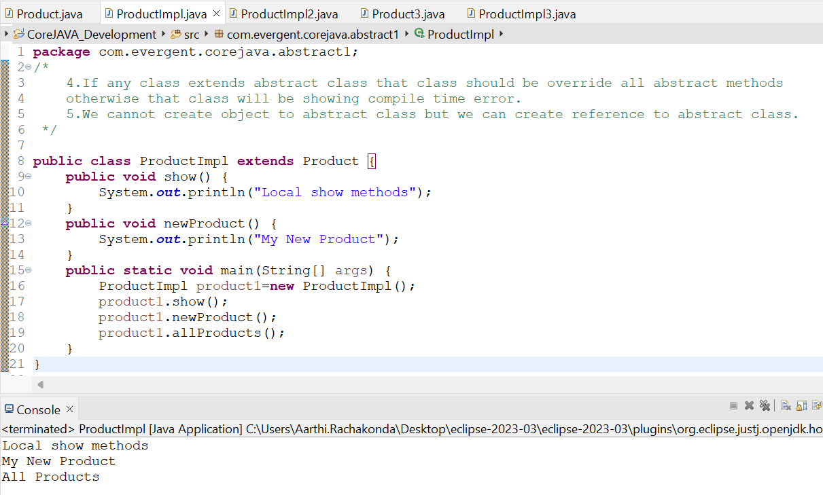

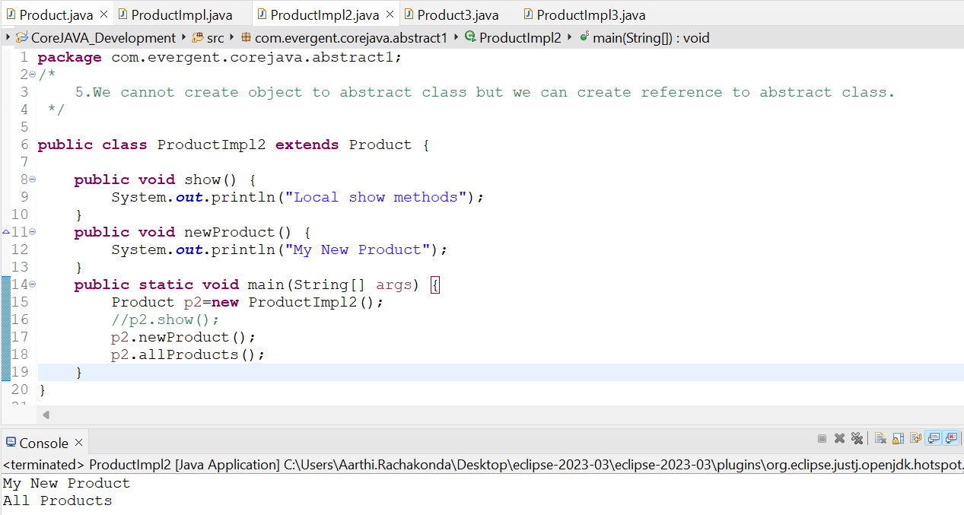

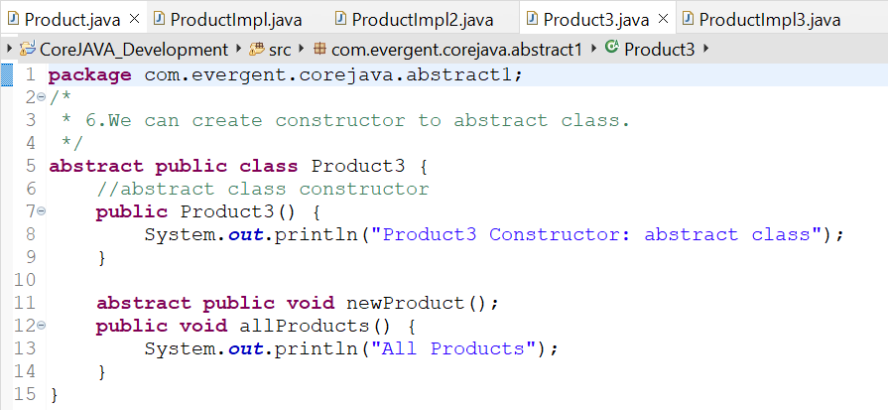

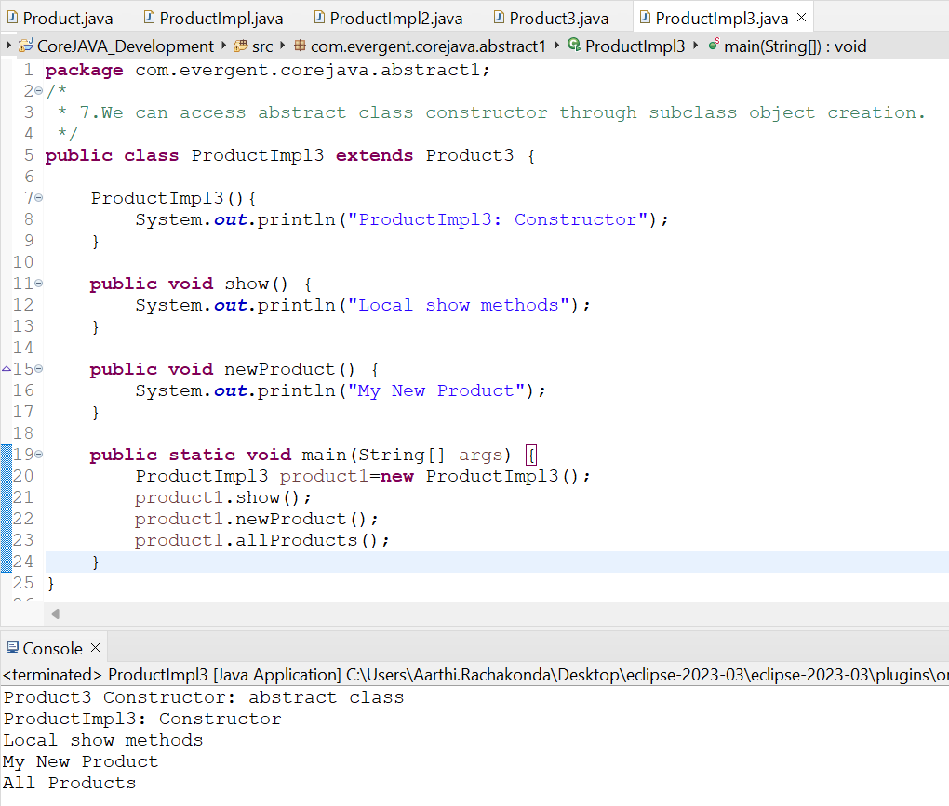

**Date 16/08/2024**

**Day-9**

**test**

**Interview questions**

**Date 19/08/2024, 20/08/2024**

**Day-10-11**

**Exception Handling:**

1. Exception Handling is mechanism
2. Exceptions are inbuilt Mechanism of Java.
3. All Exceptions are executed while abnormal conditions only.
4. Normal flow it won’t execute any exceptions.
5. Once any exceptions are occurring in java then remain lines of code in unreachable.
6. Java.lang.Throwable is super class for execution and errors.
7. There are 2 types of exceptions in java are
8. Checked Exceptions
9. Unchecked Exceptions.
10. All checked Exceptions are compile time exceptions.
11. All unchecked Exceptions are Runtime Exceptions.
12. There are 5 keywords in exception handling
13. Try
14. Catch()
15. Finally
16. throws
17. throw
18. try is for business logic
19. Catch is for handling exceptions
20. Finally is a block if exceptions is occur or not finally block will be executed
21. Throws an exception will be executed method by method
22. Throw is for runtime exceptions and will call predefined exception classes
23. Try followed by either catch or finally block
24. We should follow exceptions hierarchical
25. We can create our own user defined exceptions
26. Our own extends exception or runtime exception
27. All exception classes are into java.lang package
28. There is two exceptions in class developers should be handled first exception then after second exception should be handled.

22.Developers cannot handle errors.

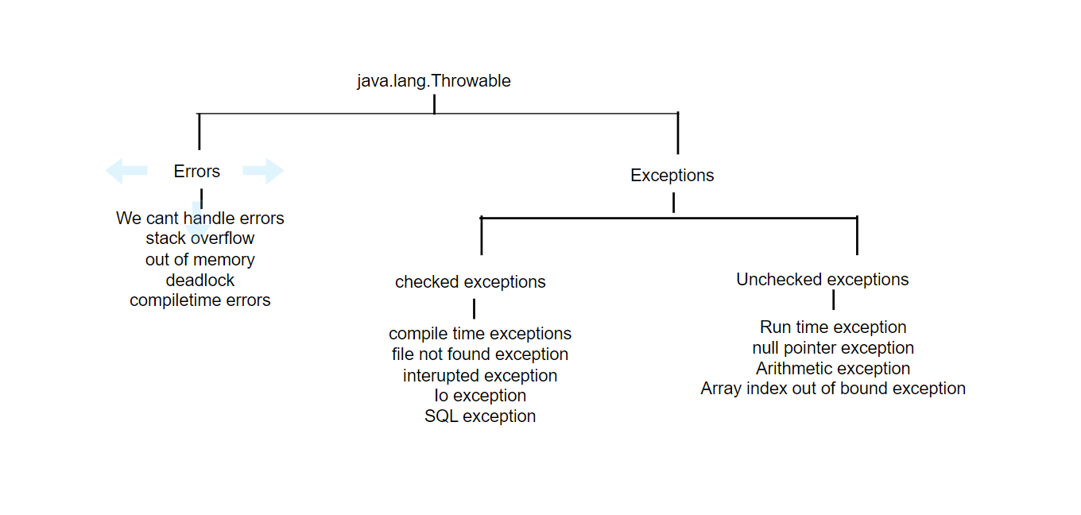

**Errors**

StackOverflowError:Error occurs when a method is called multiple times.

OutOfMemory:Error occurred when the size provided is larger than usual fixed size. Git

Used to track the application changes. Git consists of 4 stages:Working directory,staging,Local Repository,Remote repository

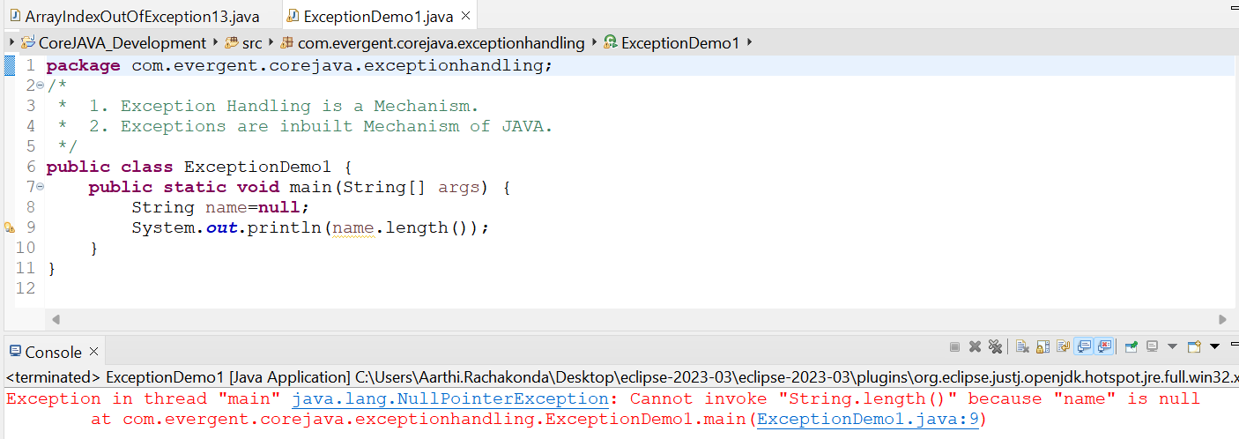

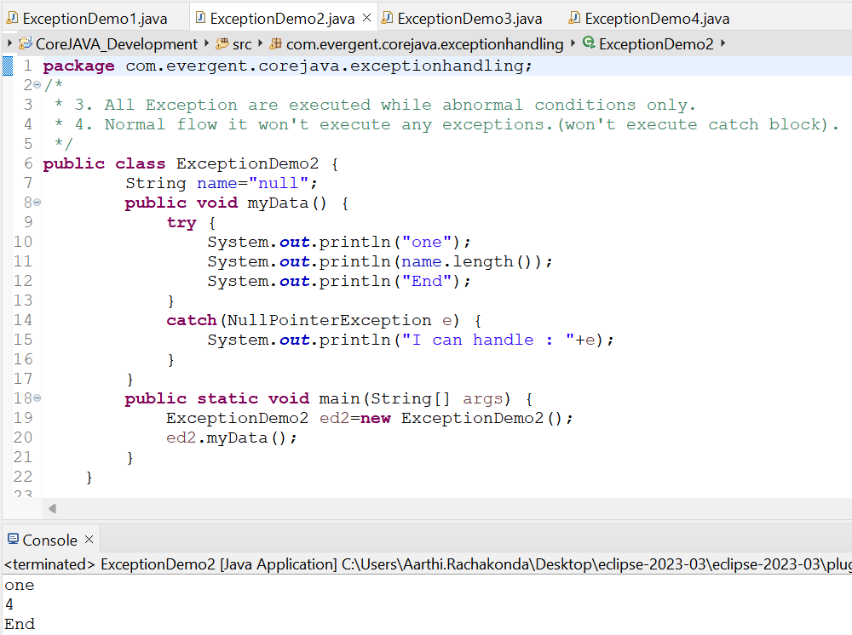

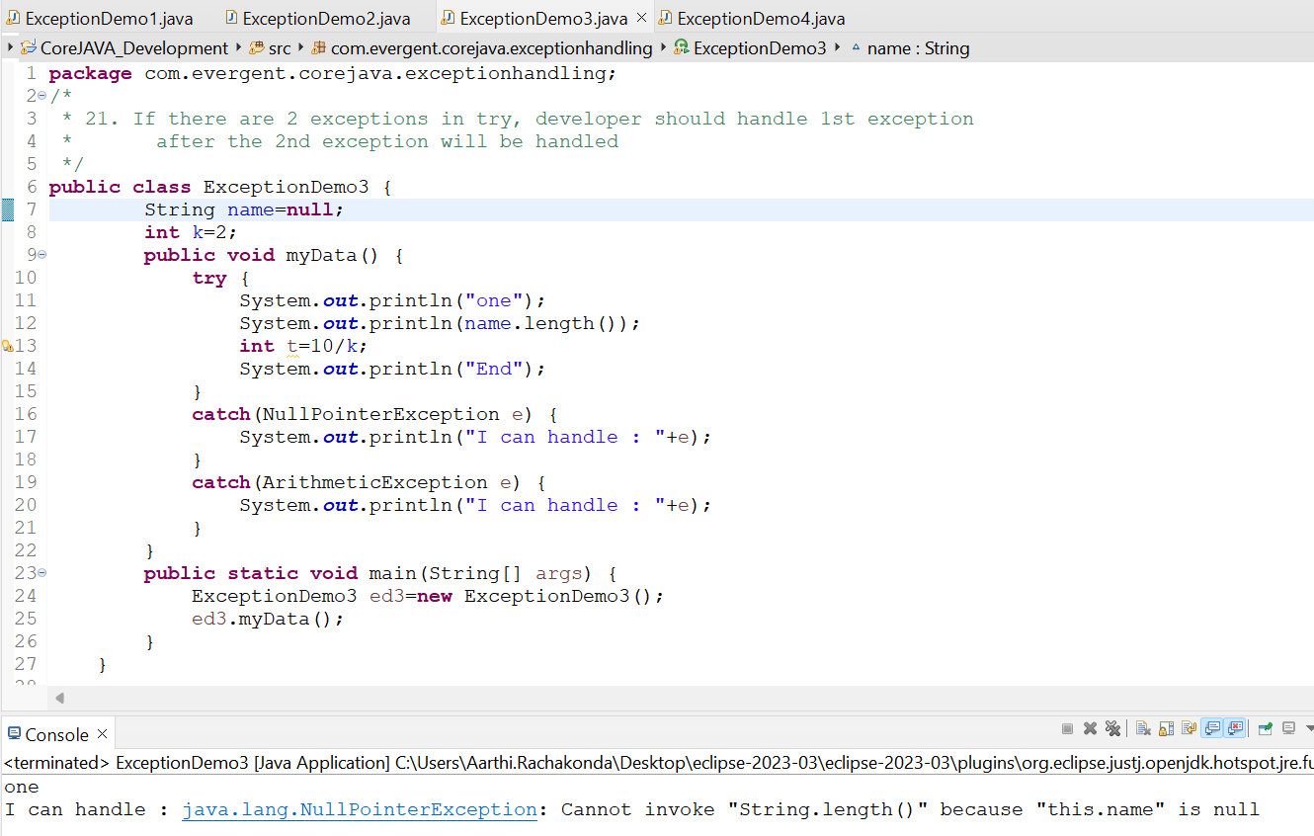

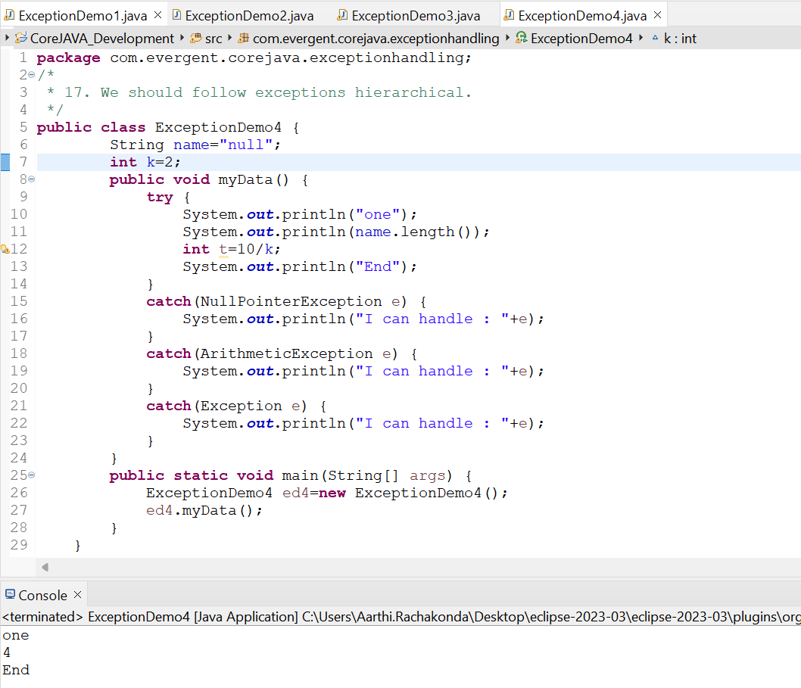

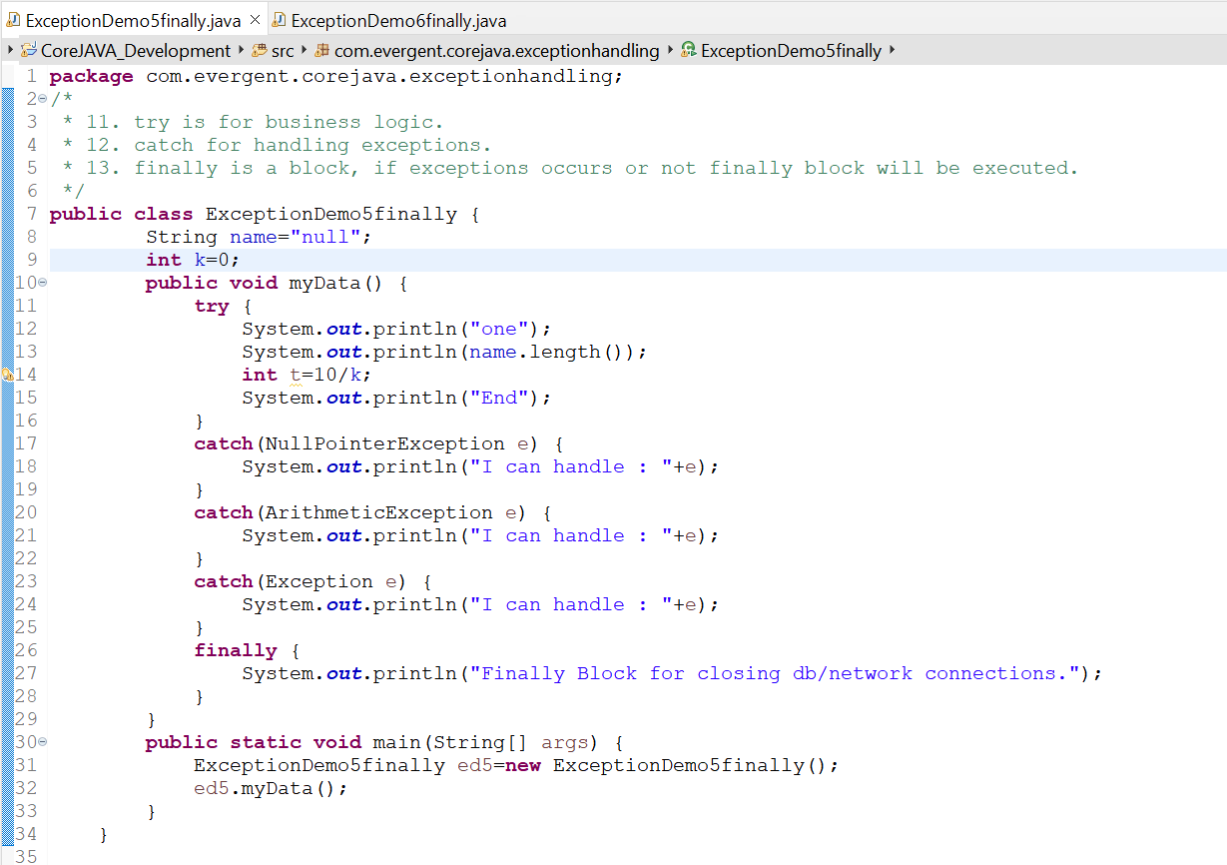

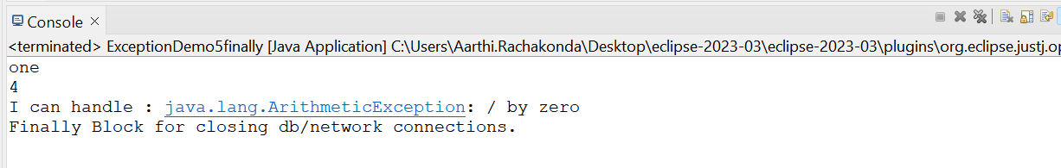

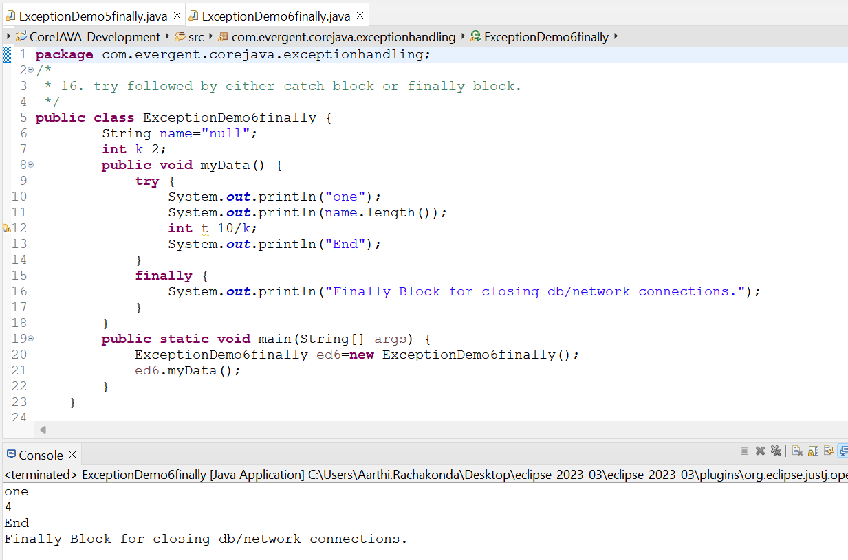

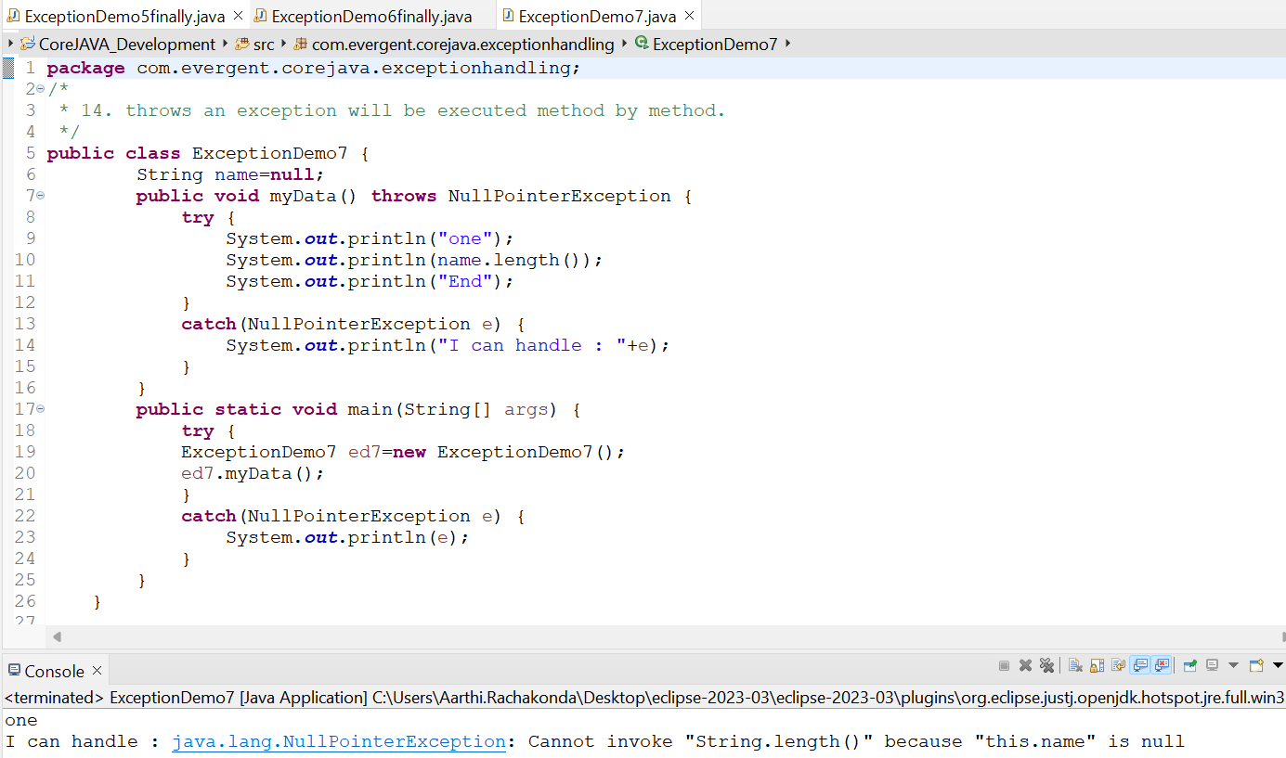

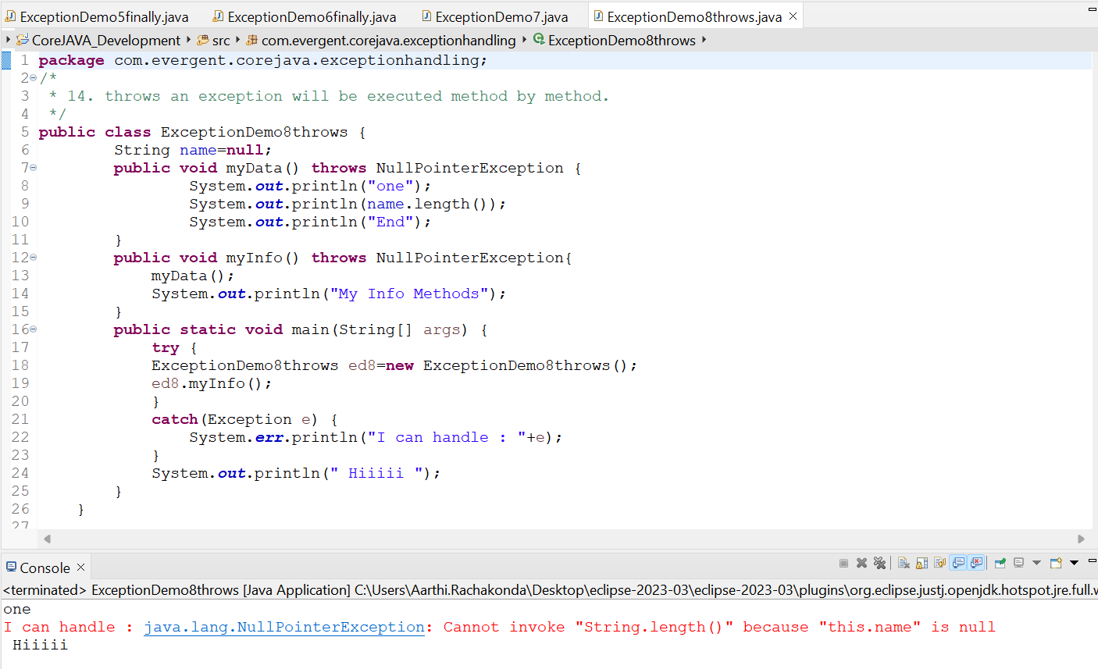

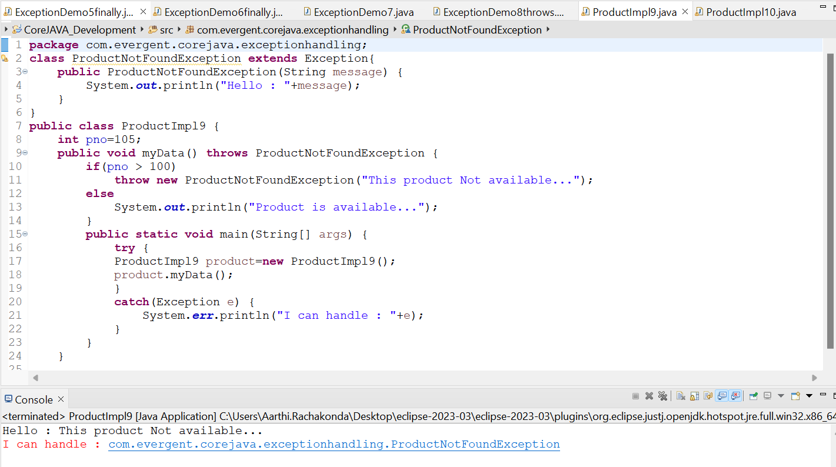

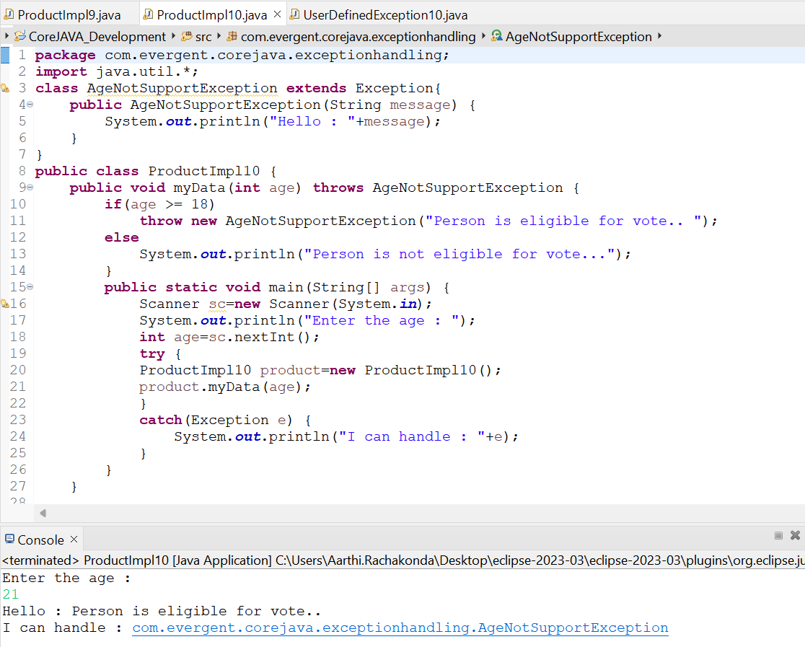

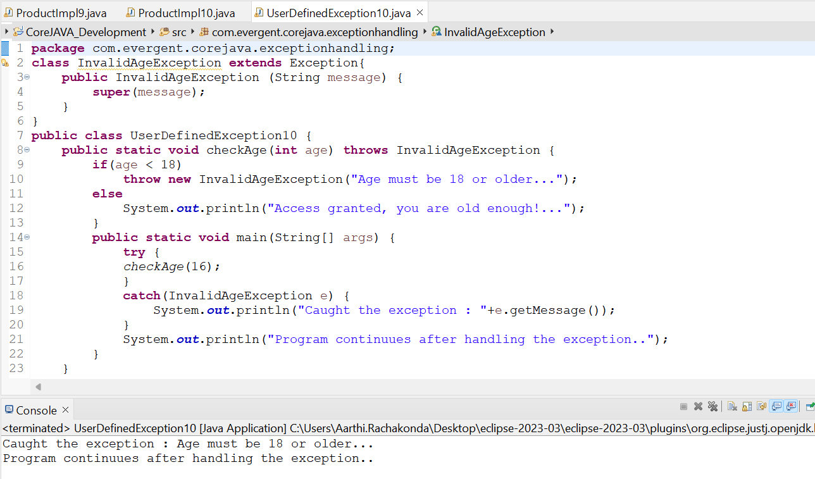

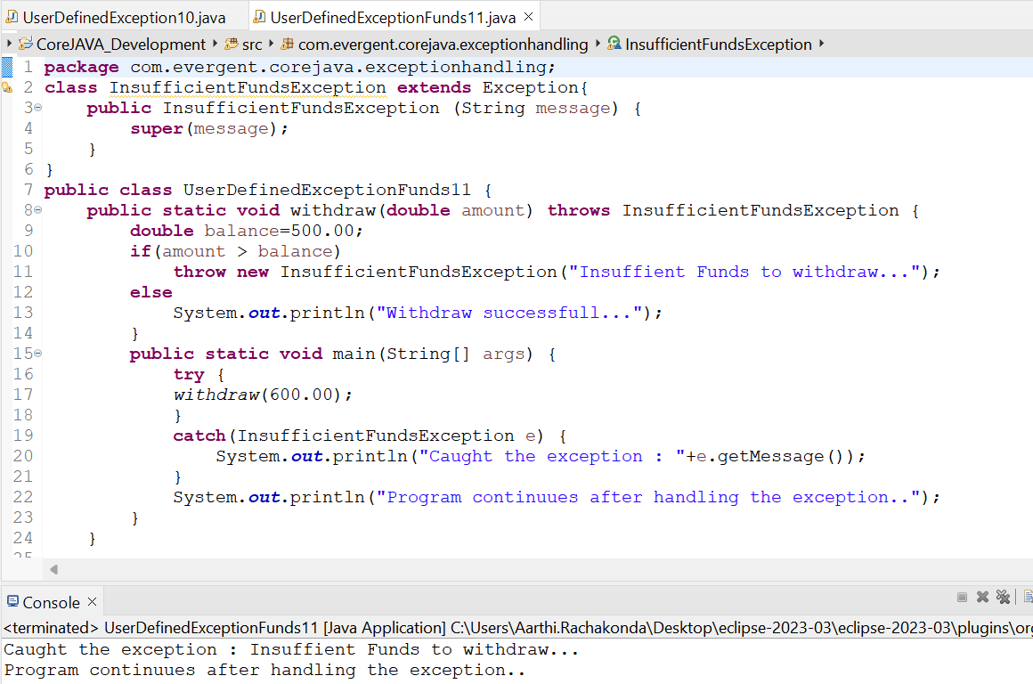

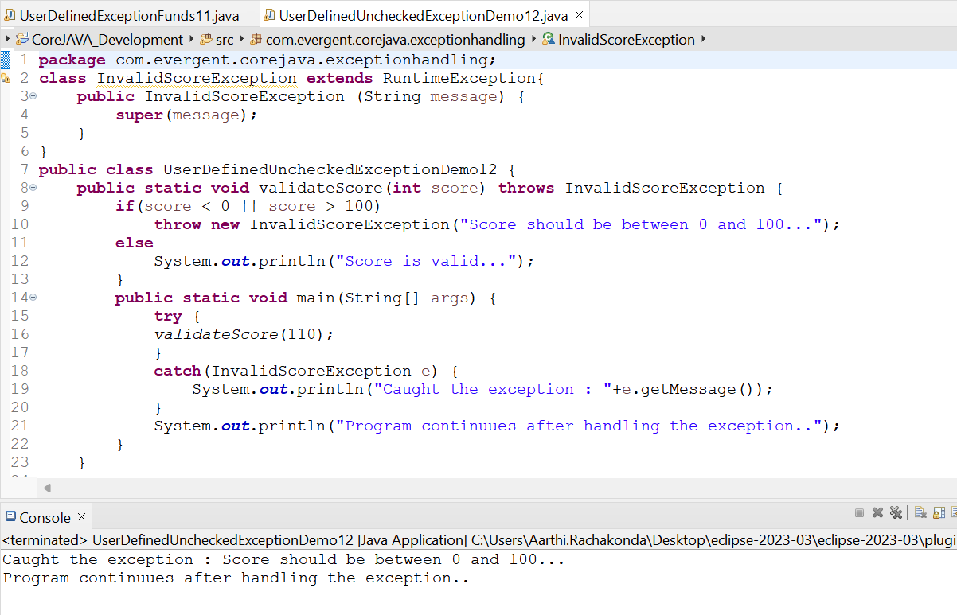

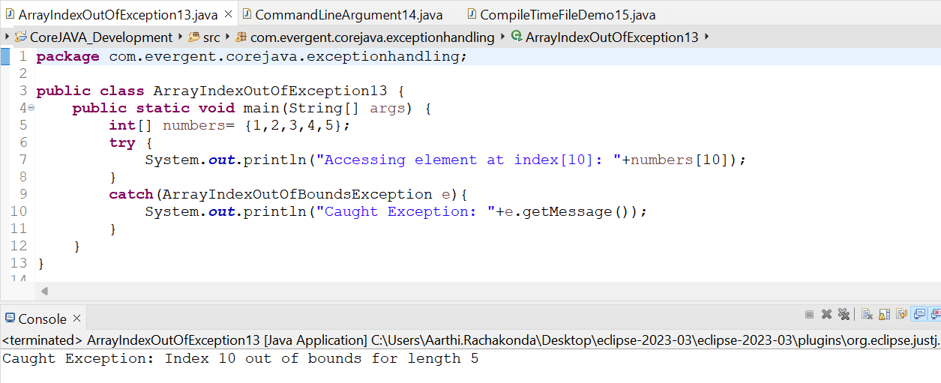

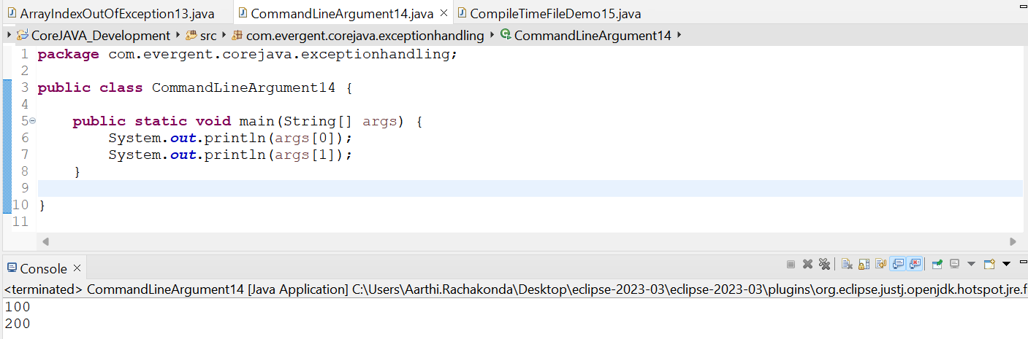

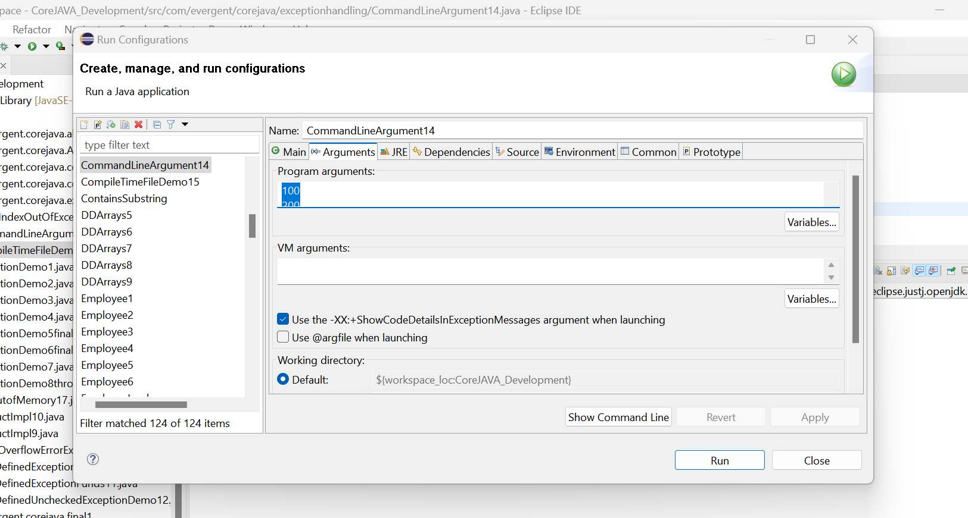

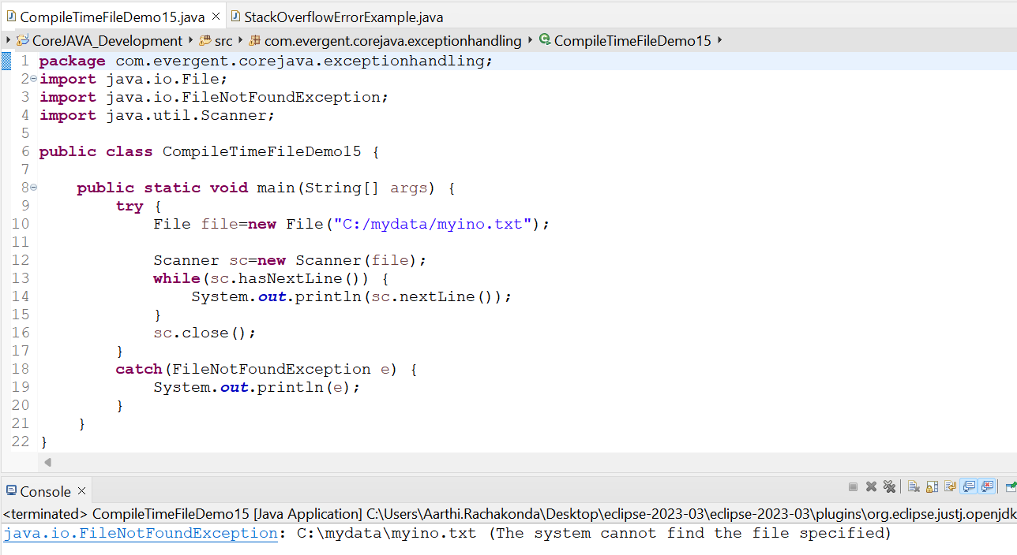

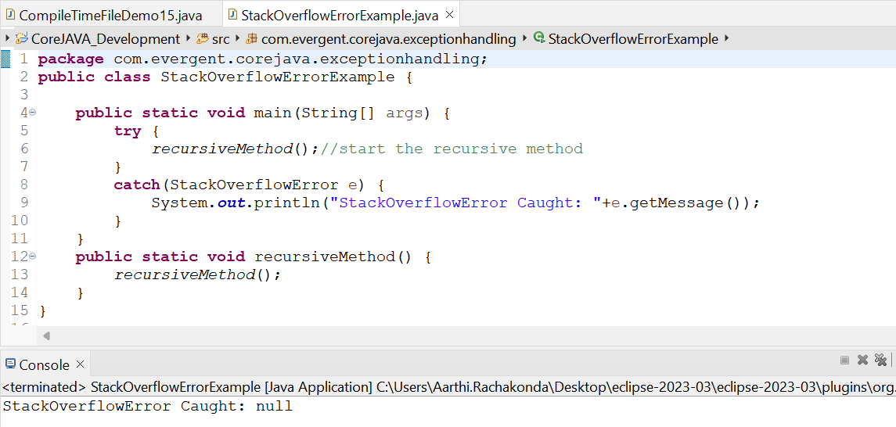

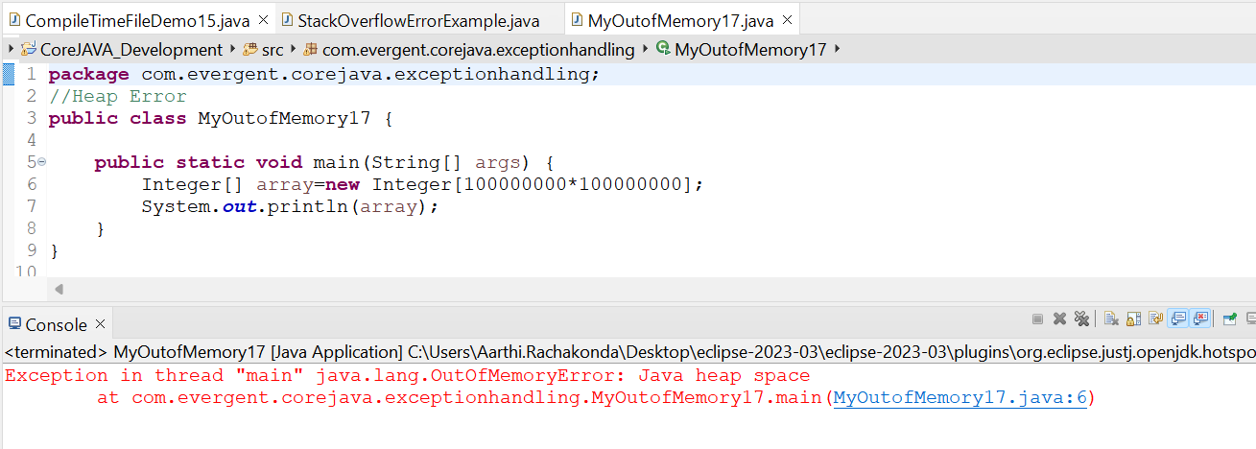

**Date 21/08/2024**

**Day-12**

**JavaBeans:**

* It is a Mechanism.
* It is light weight.
* All attributes are private.
* Get & set methods are public.
* Implement java.io.Serializable interface.
* We can achieve tightly encapsulation through JavaBean.

